BMFA Scale Indoor RC Competition Taster

Experience BMFA Scale Indoor RC Competition Flying

Rules explained and questions answered

Fly a Competition schedule in front of experienced scale flying judges

Get immediate feedback and tips from the experts
Venues
- St. Helens: Sat 25th Jan 1:00pm – 4:00pm, contact: Eric Strefford 07711 268699
- RAF Shawbury: Sun 9th Feb 1:00pm - 4:00pm, contact: Danny Fenton 07402 766399
- High Wycombe: Sat 21st Mar 5:00pm – 8:00pm, contact: Brian Seymour 07931 343199

Competition Basics:

Choose a subject model to suit your style of flying

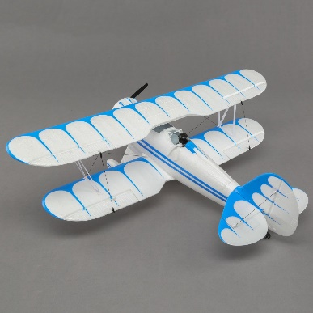
Create your competition flying schedule

Fly the schedule in the same manner as the subject

Information, and examples available to help create scale documentation for the scale class.

Suitable Models:

Any reasonable representation of a full-size model – full fuselage required

ARTF/BNF models – e.g. E-flite, Ares

Kits – e.g. Vintage Model Company, Microaces

Scratch Builds

Max. Weight – 300g

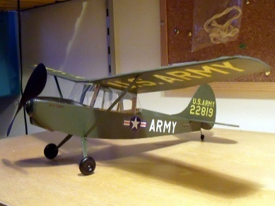
Max Wing Loading – 15g/sq.dm e.g.

Microaces Fokker D.VII: AUW 39g, W/S 14.5”, W/L = 9.0g/sq.dm

E-flite UMX Waco: AUW 98g, W/S 21.7“, W/L = 11.5g/sq.dm

Ares Fokker D.VII: AUW 29g, W/S 15.6”, W/L = 7g/sq.dm

Power; Electric, CO2, Rubber
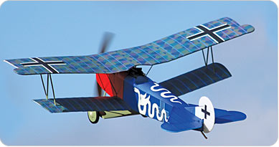
These events are a fantastic opportunity to try your hand at BMFA Scale RC Indoor competition flying. Of all the BMFA and FAI competition classes, scale competitions are the most inclusive. The key is to fly models in the same style as their full size subjects. Should your flying style be calm and sedate then choose a subject that flies in a calm and sedate manner and fly your model in a calm and sedate manner to score well. Fifty percent of the flying points are awarded for take-off (15%), landing (15%), and smoothness of the overall flight (20%). These three areas are key to scoring well.

See BMFA Scale Website for rules and further Scale Competition information: https://scale.bmfa.org/
(The new 2020 rulebook will be published in early January)

