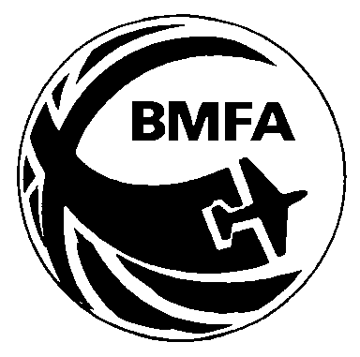 | BMFA SCALE  WORLD CHAMPIONSHIP TEAM  Preparatory Information - 2019

Any F4C or F4H competitor who is prepared to make the commitment to travel to Tonsberg in Norway for the next F4C/F4H World Championships (25th July to 2nd August 2020) is invited to complete this form.

Completed forms should be sent (e-mail or post) to the Scale Technical Committee Secretary and can be submitted any time from 1st January 2019 to the 1st October 2019.
Team members will be recommended to the BMFA Council based on qualification scores. The Team Selection Process is defined in the BMFA Rule Book 2019 edition ANNEX 6A, which can be downloaded from the BMFA website or is available as hard copy from BMFA HQ.

✈✈✈✈✈✈✈✈✈✈✈✈✈✈✈✈✈✈✈✈✈✈✈✈✈✈✈✈✈✈✈✈✈✈✈✈✈✈✈✈✈✈✈✈✈✈✈✈✈✈✈✈

I have read and understand the Team selection process.

NAME..................................................................BMFA No........................

ADDRESS.................................................................................................

POST CODE...............................E-MAIL......................................................

TELEPHONE .......................................

Enter brief details of model or models below. (NB Competitors trying for a place on both teams will require two eligible models; one for each class)

SIGNATURE ................................................... DATE: .................................

