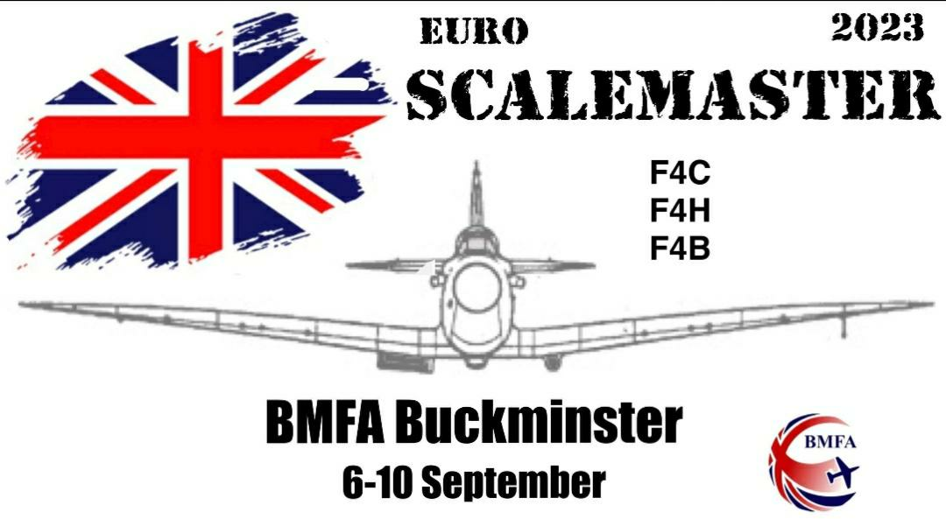
HISTORY
The Scale Masters began in 2017 and were held again in 2019. Both events were held in Helsingborgs, Sweden and incorporated the Nordic Championships. There was some participation from non-Nordic countries at both events, both in terms of competitors and judges.
FUTURE
As there are no longer Euro Scale Championships held, it is hoped that Euro Scale Masters competitions shall be held in multiple locations in non-World Championship years. These events are an excellent way to encourage international competition without the large investment of time required for a World Championship.
ENTRY FORM https://scale.bmfa.org/2023-festival-of-scale
CONTACT enquriesbmfascale@yahoo.com
PROVISIONAL TIMETABLE
Tues 5th Arrival of participants
Weds 6th Commencement of F4C/H Static from 12.00
Thurs 7th Continuation of F4C/H Static
Round 1 F4C/H
Commencement of F4B Static from 15.00
Welcome BBQ
Fri 8th Round 1 Flying Only
Round 2 F4C/H
Continuation of F4B Static
Round 1 of all CL classes
Scale FF classes
Sat 9th Round 2 of Flying Only
Round 3 of F4H
Continuation of all CL classes
Scale FF classes
Nations Night
Sun 10th Round 3 of Flying Only
Round 3 of F4C
Conclusion of all CL Classes
Awards and Prize Giving

