Indoor Scale Nationals News  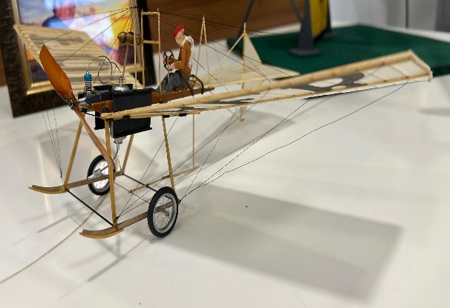 Keeping you informed with the planning and progress for the 2026 BMFA Scale Indoor Nationals |  |  |  | February 2026 – number 2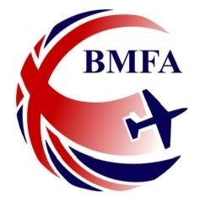  IN THIS ISSUE  Notes from the Organising Team  HOT OFF THE PRESS – 2026 BMFA Scale Rule Book now published, and entries so far…….  “News from the flightline” and more  North West Gala 2026 – Scale Indoor Free Flight at Manchester Velodrome
Notes from the Organising Team  By Paul Rich |  | The 2026 Scale Rule Book is now available and can be viewed at 2026 SCALE MODELLING RULE BOOK . A huge thank you to Mike Smith for all his diligent work in ensuring the rule book is updated. Mike has already started work on the 2027 Scale Rulebook…………😊 You will find all the rules applicable to the Scale Indoor Nationals on pages 53-57 for Scale Indoor RC and pages 100-115 for Scale Indoor FF.  As of the time of writing we have already received 31 entries for the Scale Indoor Nationals compared to 24 entries at the same time in 2025! The entry form for entering the Scale Indoor Nationals can be accessed at: BMFA 2026 Scale Indoor Nationals Entry Form  For further details and news on the BMFA Scale Indoor Nationals keep an eye on the BMFA Scale Technical Committee, (STC) website at:  https://scale.bmfa.org/
In

 |  | News from the flightline
The North West Gala  By Paul Rich  Organised by the BMFA North West Area and taking place at the stunning Manchester Velodrome The North West Gala is rapidly turning into a highlight of the Scale Indoor calendar.  It will take place on Saturday 14th March between 9:00 and 17:00. We will be running the following Scale competitions:  - Scale Free Flight Open (flying only), competing for the David Lloyd-Jones Cup  - Peanut Scale, competing for the Modellers Den Peanut trophy – Mike Stuart has won this for the last two years - who will challenge him in 2026 and take this impressive Trophy home?  - Pistachio Scale – BMFA Gold, Silver and Bronze Certificates for podium places.  For 2026 a new Trophy will be up for grabs at the Gala. The Roy Lever Jet-X Trophy will be awarded to the competitor who in the opinion of the Judges and Contest CD displays the “Spirit and endeavor of Scale aeromodelling.”  The Gala also provides a wonderful opportunity to trim out your model in advance of the Scale Indoor Nationals.  For further information regarding the North West Gala, contact the Contest CD, Dave Whitehouse at whitehousejdavid@googlemail.com |  | News from the flightline and more  By Paul Rich  Traders announced for the Scale Indoor Nationals 2026  We are pleased to announce that the Vintage Model Company have confirmed they will be attending the Scale Indoor Nationals in April.  Hadi Kanan will be attending with a stall selling all the aeromodelling goodies that VMC are well known for.  If you want something special VMC will provide a click and collect service. Hadi has requested that anyone wishing to make use of this service please call VMC directly on +44(0)1629 258240 to avoid any disappointment.  If you are looking for a project for your next indoor scale model, or wish to simply see the full range of goods VMC has to offer, why not have a look at the VMC website for some inspiration?  https://www.vintagemodelcompany.com/  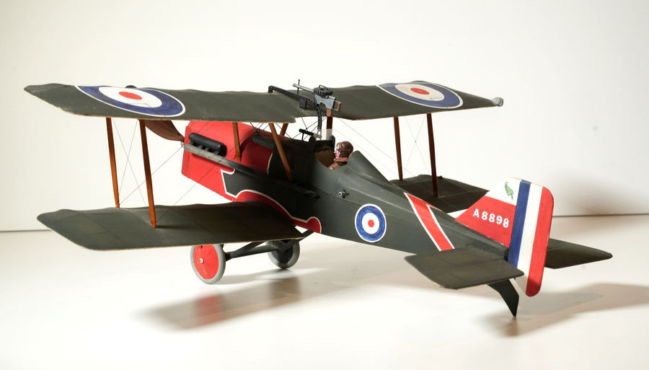  Paul Briggs, a regular Static Judge at the Scale Indoor Nationals. Built the superb SE5a in the photo above from the VMC Magnificent Flying Machines kit, (designed by Andrew Darby),  We also hope next month to announce some further exciting news about additional traders we are in communication with regarding attending the Scale Indoor Nationals.

Plan of the month – Comet Westland Wallace  I love a good Swap Meet and recently attended the Telford MFC event held in Shifnal Shropshire.  Often Swap Meets tend to be very much outdoor RC orientated but to those who like a challenge and are prepared to search through boxes and under tables there are often some real gems waiting to be discovered!  I was overjoyed to find a vendor selling older free flight scale kits, from both UK and American manufacturers, many of the kits dating from the prewar period.  I spied a vintage Westland Wallace Comet Kit in his box of goodies.  Developed by Westland as the successor to the Wapiti, The Wallace was the last of the interwar general-purpose biplanes.  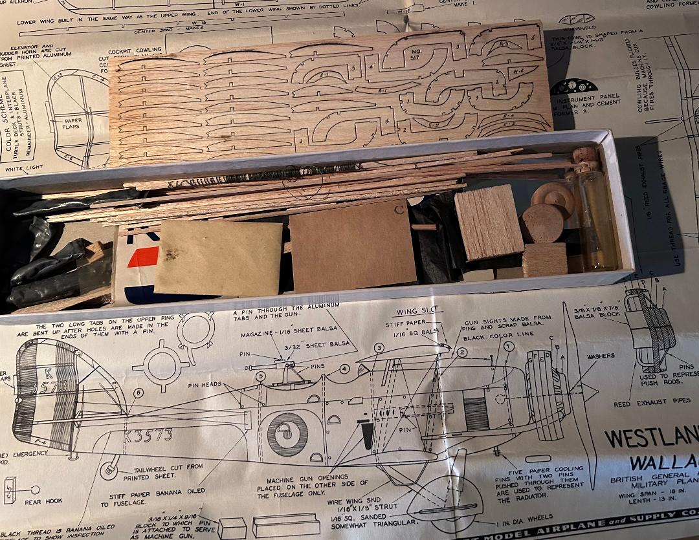  Designed by Alex Horback and first kitted by Comet in 1935, the contents of the kit were complete, even down to including a glass phial of dope, which I’ve not opened!  The Westland Wallace plan is available online and can be downloaded from the wonderful Outerzone website:  Oz: Westland Wallace plan - free download  Comet produced lots of interesting and unusual Scale free fight designs that are most suitable for conversion to Scale Indoor RC and would make unusual and striking Kit Scale Models for both RC and FF. you can view and download these plans on Outerzone - Oz : Free plans : Collection of free vintage model aircraft plans to download |  |   YouTube Inspiration – video of the month  This month’s video comes from the National Free Flight Society’s You-Tube channel.  Based in the USA and formed in 1964 the National Free Flight Society actively promotes free flight as an aeromodelling discipline.  Rubber Power Scale Construction Techniques is an interesting video that covers a range of techniques that are interesting to view.  Please don’t be put off with the 80’s background music, it is well worth the effort to watch it through to the end.  https://www.youtube.com/watch?v=4qpwBLa6c-k  We will be back in March – look out for the next Newsletter!  Until then happy building and flying; may all your skies be blue  News from the flightline (continued)

