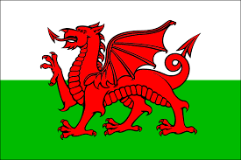

](https://justiceuk-my.sharepoint.com/personal/paul_rich_justice_gov_uk/Documents/North%20East%20Dev%20Coaches/North%20East%20Skills%20Matrix%20Master%20.xlsx?web=1)

***MAY-WELSH***

***Scale Free-Flight Extravaganza!***

***9th -12th May 2025***

***Bethesda and Bangor,***

***North Wales***

***Contact: Martin Pike***

***at*** [***members@sam1066.org***](mailto:members@sam1066.org)

***or 07831 141418***

***for more details***