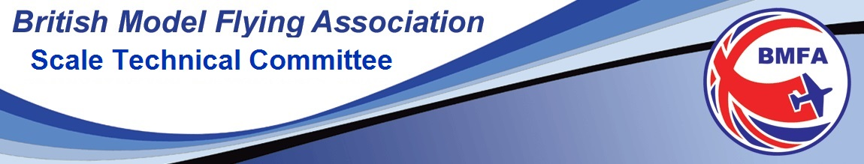
Newsletter March 2020
The STC traditionally have sent out Newsletters on an ad-hoc basis and they are generally a mix of meeting/competition reports and upcoming event dates, venues, announcements and changes to rules etc. They also should encompass all the varied disciplines of scale modelling from RC through CL and FF. As the new PRO for the STC, I will be using as many of the varied methods and media as is possible to get news and information out to you all. This means using the website, newsletters, and email broadcasts (for those who agreed to the GDPR constraints last year) and Face Book.
Please take a look at the website :- https://scale.bmfa.org and if you have not already registered to receive notifications and you wish to be kept informed of all matters scale, then please register there for the email updates. Also, you can give me permission to put your details onto the STC emailing list.
This issue of the Newsletter, being the first in 2020 and will be my first too, so if anyone has information they want to get out to the wider scale audience please drop me a line to j.minchell@btinternet.com. I think in the universal effort to recruit new members and more new competitors in scale, then Scale Fly-Ins and gatherings such as Old Warden Scale Days, should also be a part of this process. Anything from the Nationals to a club scale fly in – is fair game, please let me know and I will endeavour to get it publicised & spread the word for you.
The items in this newsletter are;
- World Championship F4H team for 2020 Norway
- North West Area FF Gala at the Velodrome March 7th
- New Scale Groups on Face Book
- Scale uncovered March 15th
- New STC Secretary Doug Hunt

- World Championship F4H team for 2020 Norway

The FAI F4 Scale World Championships will be held at Jarlsberg Flying Sports Centre Tonsberg Norway on July 25th till August 1st 2020.
The Scale Technical Committee are pleased to announce that the team who will represent Great Britain in the F4H class are Steven Jackson, John Carpenter and Richard Crapp.
All three are experienced Scale competitors and John and Richard have represented their country before at world level. Their models are in the pictures below and we wish them all an enjoyable and successful trip. Not only will they be competing for individual honours but they will also be going for the team prize.
The Team Manager for the competition is Graham Kennedy. He has a scale CV in judging and organising at the highest level and certainly as long as anyone currently in the sport.

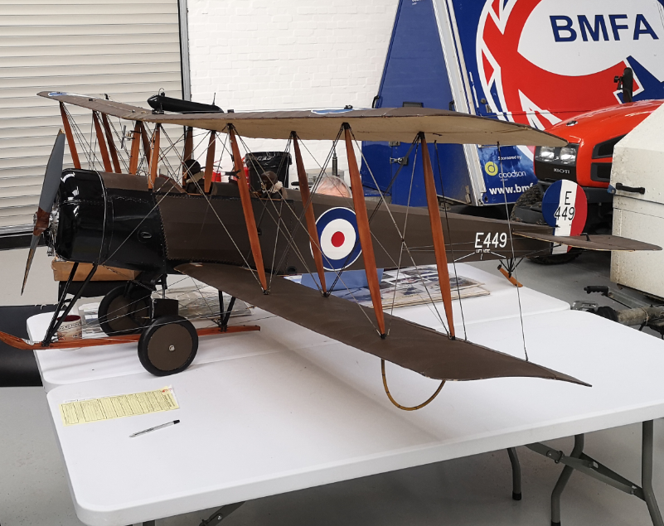
Steve Jackson’s Avro 504
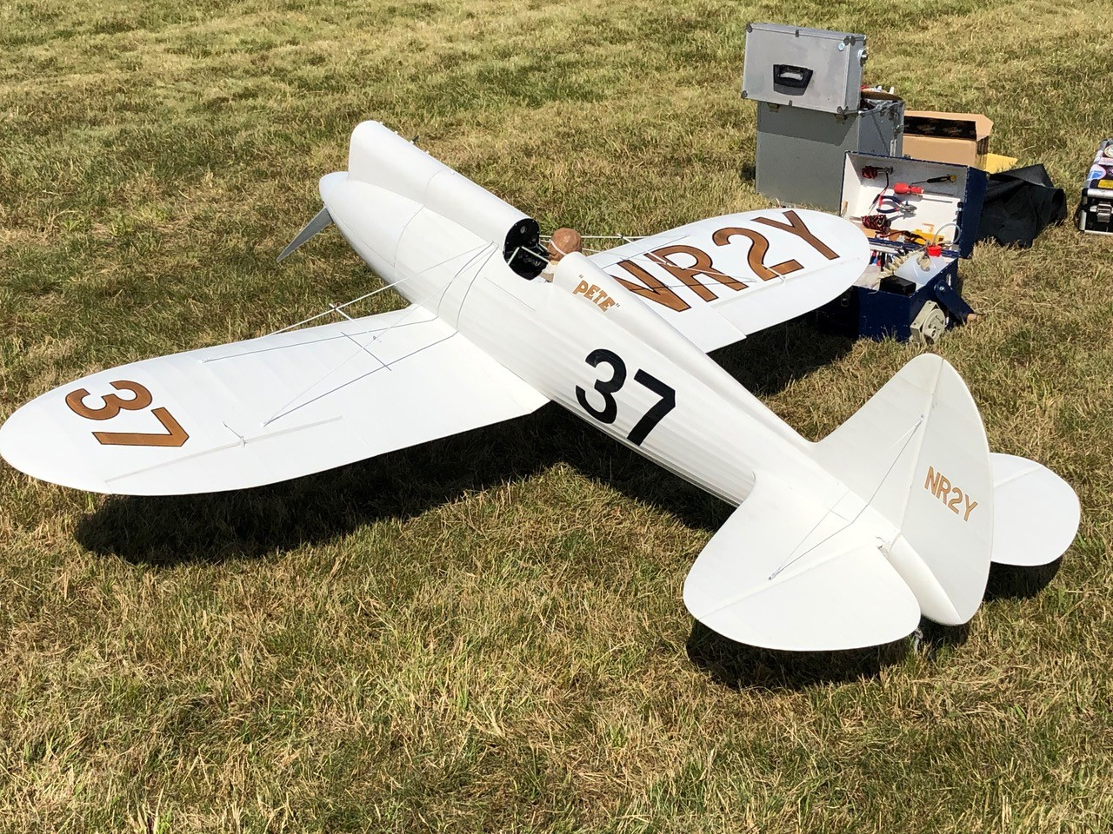
John Carpenter’s Howard “Pete”
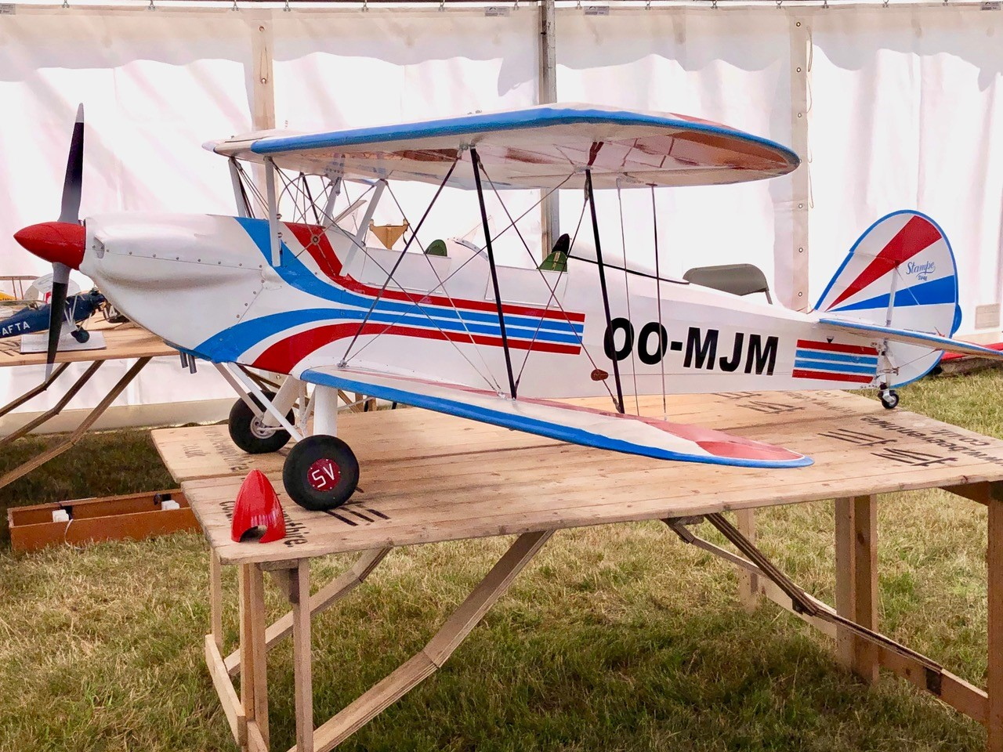
Richard Crapp’s Stampe
-------------------------------------------------------------------------------------------------------------------------------------------------------

- North West Area FF Gala at the Manchester Velodrome March 7th

The BMFA NW Area Gala is an Indoor Free Flight Competition for Scale and Duration models, run by the BMFA Indoor Technical Committee, with assistance from the BMFA NW Area and BMFA Scale Technical Committee. Any BMFA member can enter and spectators are more than welcome.

Classes being flown are:
Scale Models
Peanut & Pistachio with Static Scale Judging & timed flights. Flying only is for the Open Scale classes (Rubber & CO2/Electric) and Kit Scale with no static element, but judged flying.
Duration Models
Limited Penny Plane, F1L, F1M, F1D, No-Cal, Legal Eagle, Osprey and Bostonian.

A first opportunity to try out that new Starter No-Cal model that you have built for the Indoor Scale Nationals. Starter No-Cal models (STC Rules) may enter the NW Area competition (which is traditionally run to the ITC 4gm min rules), albeit with a 2gm weight disadvantage, but still a good trimming opportunity.
Cost is £25 for the day for as many classes as desired, anyone entering one event - £15 entry fee.
Contact: John Minchell email j.minchell@btinternet.com tel 07989 744251

Schedule for the NW Area Gala

9.00 – 10.45 Registration and set-up
9.00 – 10.45 Pistachio, Peanut, No-Cal, Legal Eagle, Osprey, Bostonian (including Scale Trimming)
10.45 – 12.00 Rounds 1 & 2 Open Scale flying, immediately followed by Pistachio, Peanut, No-Cal, Legal Eagle, Osprey and Bostonian (including Scale Trimming)
12.00 – 1.15 Round 1 Duration (F1D, F1L, F1M, Limited Penny Plane)
1.15 – 1.45 Pistachio, Peanut, No-Cal, Legal Eagle, Osprey, Bostonian (including Scale Trimming)
1.45 – 2.45 Round 2 Duration (F1D, F1L, F1M, Limited Penny Plane)
2.45 – 3.30 Rounds 3 & 4 Open Scale flying immediately followed by Pistachio, Peanut, No-Cal, Legal Eagle, Osprey and Bostonian
3.30 – 4.45 Round 3 Duration (F1D, F1L, F1M, Limited Penny Plane)
4.45 – 5.00 prize giving

---------------------------------------------------------------------------------------------------------------------------------------------

- New Scale Face Book Groups
At one of the STC meetings late last year, it was agreed that more different forms of media and communication should be utilised to try and get the word out to more people (general BMFA members and scale club flyers). So, as we already had a website and an email list, but neither would reach everyone, Face Book was next on the list.
So, three new Face Book groups were set up for different types of scale modelling disciplines.
BMFA Scale; Scale indoor free flight - UK and Scale Indoor R/C – UK, all run by extremely well qualified people in each discipline. These are respectively Graham Kennedy, Mike Stuart and Danny Fenton, so many thanks to them for setting the FB groups up, taking the time to publicise and invite the initial members and for administering them.
Please take a look and support them by asking to be added to the group. They are a very useful tool in their ability to post a question and get a pretty quick response from other modellers who have overcome the problem. A great way to learn the techniques and working methods of the experts and to see what projects and models across the size spectrum, from indoor free flight Pistachios, up to giant LMA size models. Some breath-taking models and skill sets on display.
BMFA Scale is here https://www.facebook.com/groups/2457811227878150
Scale indoor free flight – UK is here https://www.facebook.com/groups/441957813162158
Scale Indoor R/C – UK is here https://www.facebook.com/groups/619252605230388

----------------------------------------------------------------------------------------------------------------------------------------------
- Scale Uncovered March 15th
Graham Kennedy is running a training event at Buckminster aimed at the newcomer to a Scale competition, for those who have never competed in a static judged class. For grass roots level modellers upwards, to help people learn and take away the myths and barriers to entering a scale competition.

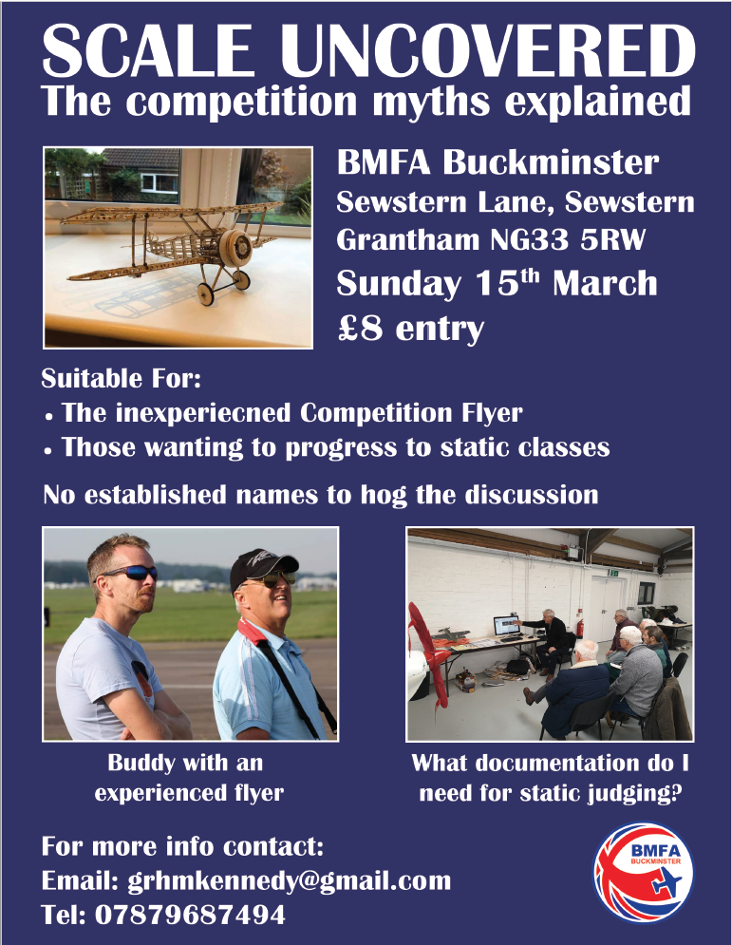

- New STC Secretary Doug Hunt

My name is Doug Hunt. I am 69 years old. I've been an aeromodeller since I was 14, initially KK Flying Scale then gliders and sport power models. Moving to the Midlands brought membership of the SMAE in 1967 and control line sport/combat but gaining scale inspiration from the masterpieces of Handsworth club mate Tony Day who sadly passed away very recently. A post grad move to Derby Rolls Royce, marriage and membership of Nottingham MAC was accompanied by a mounting interest in Indoor Scale fuelled by a meet with the maestro Butch Hadland when the UK Peanut movement was gaining momentum.
Rolls Royce work as a physicist on design and development of submarine reactor plant (plus testing on the Euro-fighter engine) was followed by operation of a successful 20 year nuclear safety consultancy until retirement in 2017. During that time I have organised indoor scale competitions, initially sourced venue and subsequently run monthly Nottingham University indoor meetings for some years. I was instrumental in seeding the Inter-Scale concept with the late Doug Sheppard, STC chair, then part of the organising team for the highly successful Inter-Scale meetings of 1991 and 1993. Initiated the resurrection of the Eddie Riding event, judged and CD'd a number of recent indoor and outdoor competitions.
So, in retirement and with my scale competition, judging and organisational experience spanning nearly 4 decades, I am now trying to put more back into the BMFA by working on the STC to develop UK scale flying with a focus on the FF scale disciplines and attracting new people to scale.
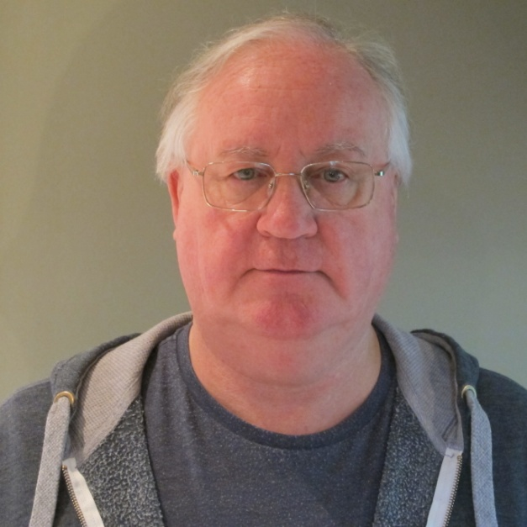

------------------------------------------------------------------------------------------------------
I hope that the building season has been productive for you all (how many have been building float planes in response to the February floods)? We are all looking forward to the better weather, a good flying season and the upcoming Indoor Scale Nationals in Walsall – more in the next Newsletter.
John Minchell
Scale Technical Committee PRO

