Outdoor Scale Free Flight
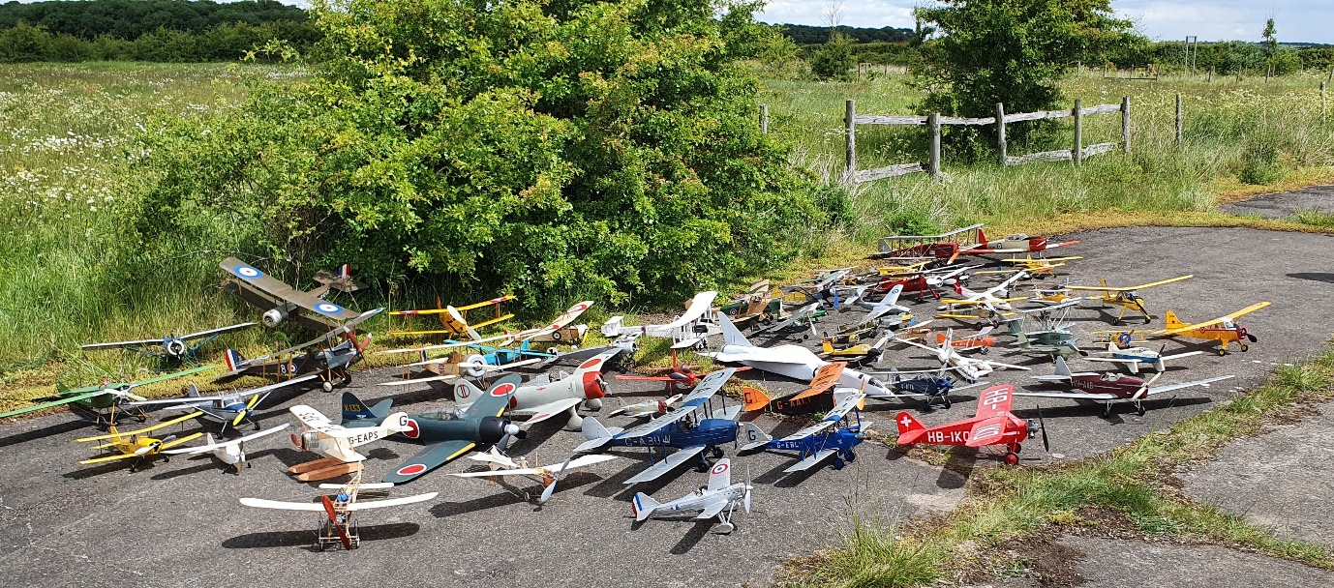
A collection of 61 Scale Free Flight models celebrating the BMFA 100 years.
The free flight class of model can provide a very wide range of subjects to build, be they scratch built by the modeller, built from a plan or from a kit. With the introduction of modern technology in the form of a gyro this range of subjects has been expanded to the more unstable types previously not contemplated.
The cost of such models can be quite modest relatively speaking, compared to the radio-controlled type, and can be well be within the budget of most pockets. If flying scale models interest you there is always an option to get started and advance further up to the Open classes.
For outdoor competition within the BMFA there are many varied classes of power and build complication from Flying Only to the Open Classes that decide National Champions.
Listed below are brief explanations of each class in the BMFA rule book. The rule book is available via this link -----------------

Outdoor Free Flight Open Classes
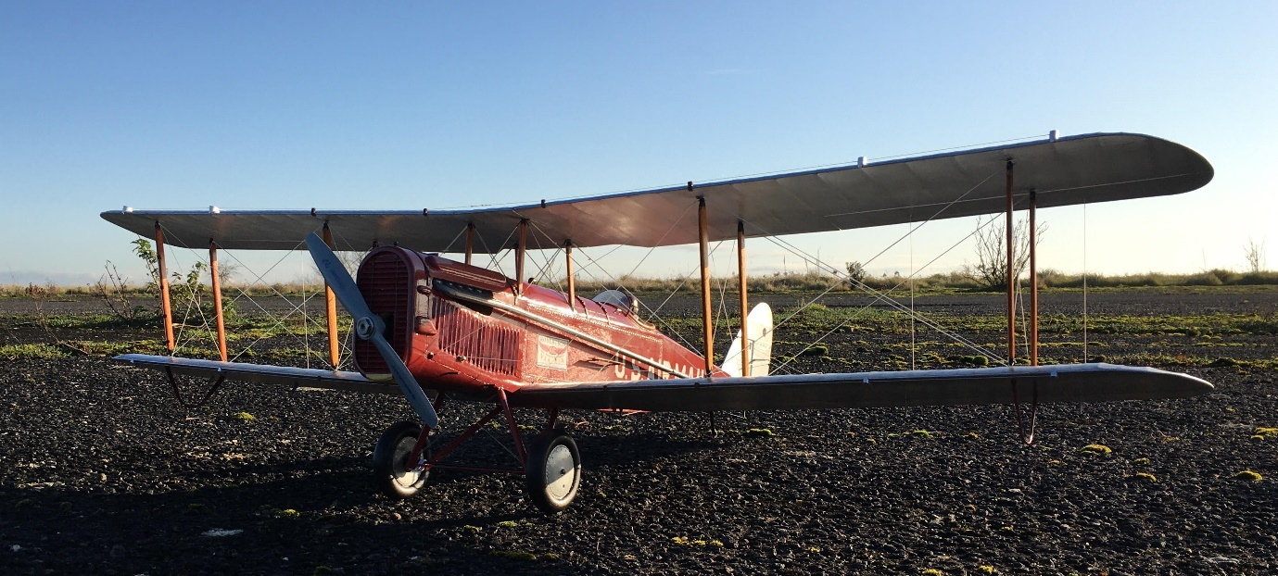
Mike Smith’s US Airmail DH4 in the low light at North Luffenham
There are three classes. FF1 Internal combustion powered, usually a diesel.
FF2 Rubber powered and FF3 Co2/Electric powered.
In these classes the competitor is required to provide comprehensive documentation to enable the static judges to accurately assess the build accuracy and realism of the model. This is now a much simpler task with the availability of the internet than it was in the past, as long as the subject chosen is not too obscure. 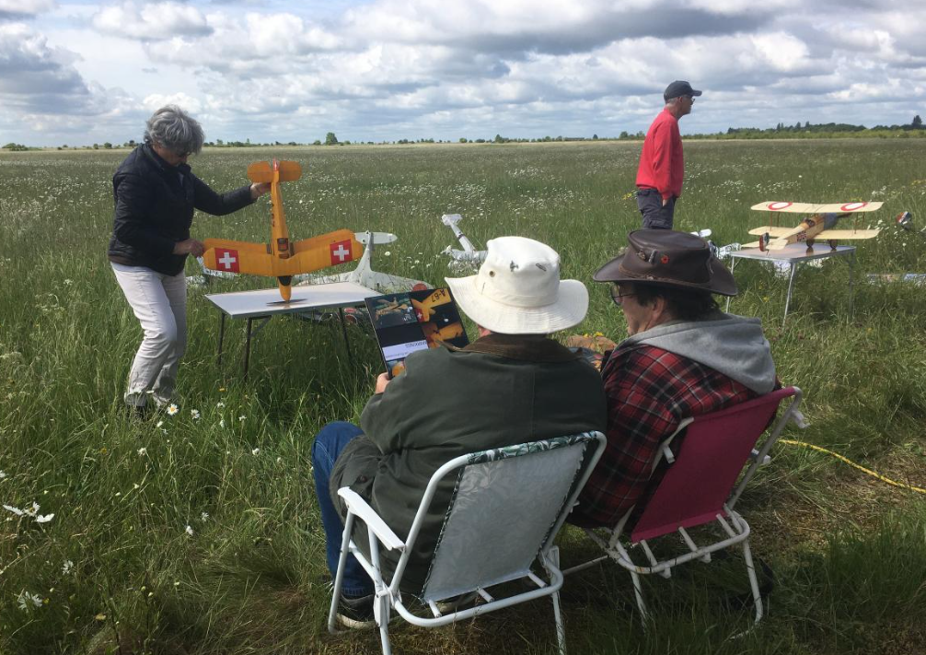
Static Judging for the Eddie Riding contest at North Luffenham
The flying part of the contest is judged on the best flight from 4 or 6 rounds for take-off, when a run way is available, if not, models are hand launched, Initial climb, cruise, descent to landing and realism in flight. The landing is not judged.
The static score is added to the flying score to give a total score.

FF4 Intermediate class. 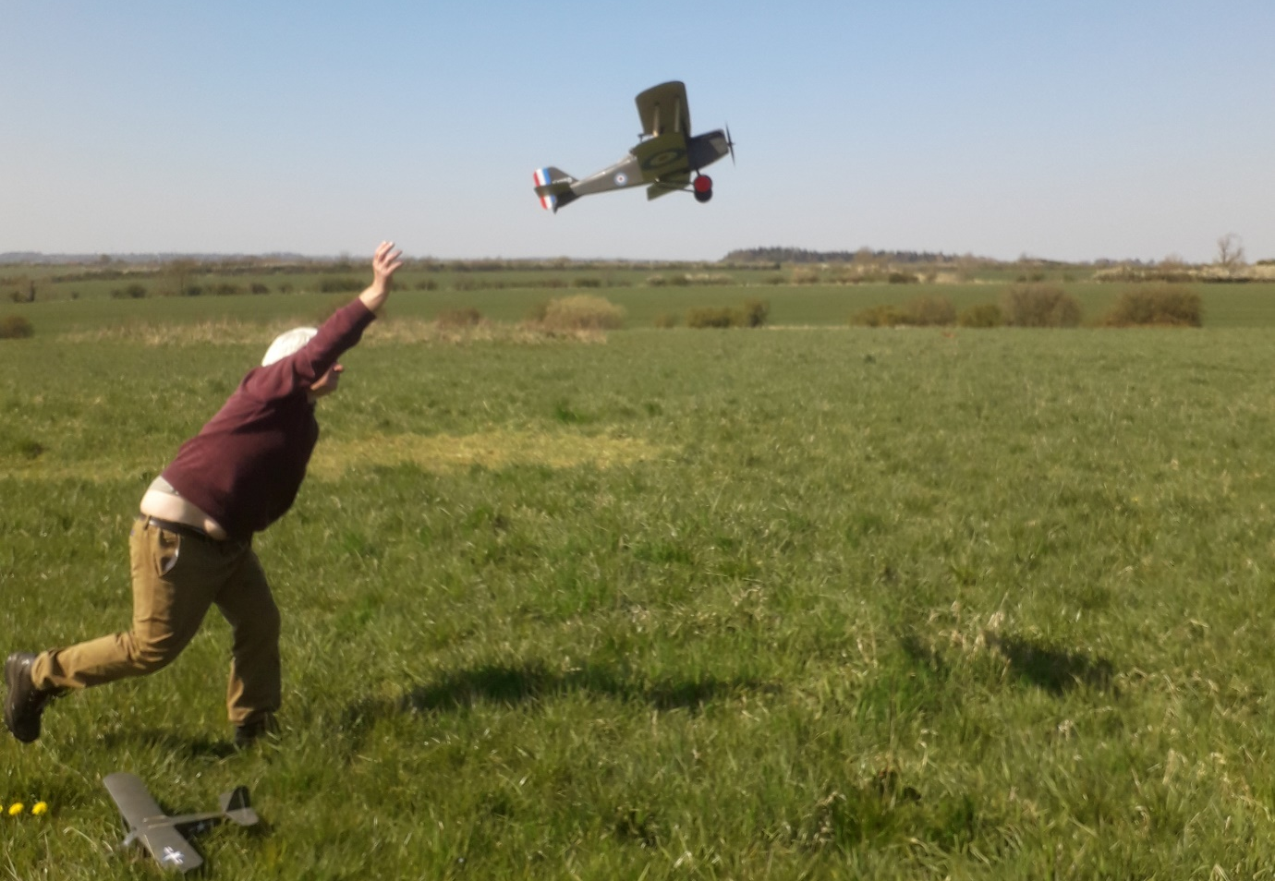
Ivan Taylors SE5a at the BMFA National site at Buckminster
This is similar to the open classes with all the various power sources in one class and a much less stringent requirement for documentation. This class provides a stepping stone and would be suited to the modeller wanting to progress from Flying Only to the Open Classes. It also allows models that are more obscure with a minimum documentation available to compete. If your scale model is of a good standard but not competitive in Open Class, built from a kit for instance, you can still have a chance to do well.

FF5 Flying Only
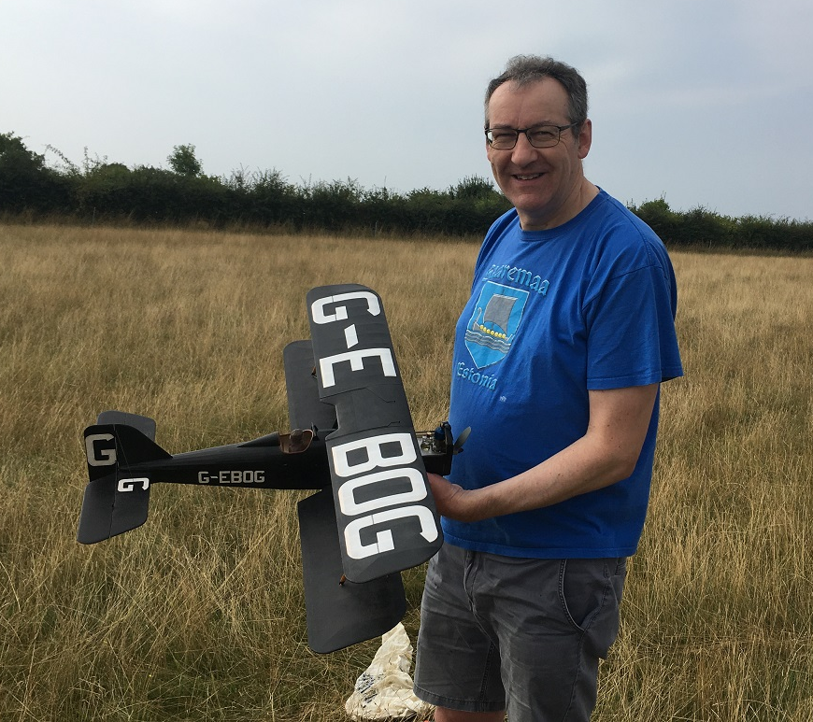
You need a sense of humour in Scale Free Flight. Mike Kelsey with his Post WW1 SE5a.
This class has proved very successful over the years. If you have a recognisable scale model within the model characteristics specified in the rules, then you can compete in this usually very laid-back competition where only the flying is judged with emphasis on realism in the air. No take-off required, which suits most of us.

FF6 Kit Scale Precision
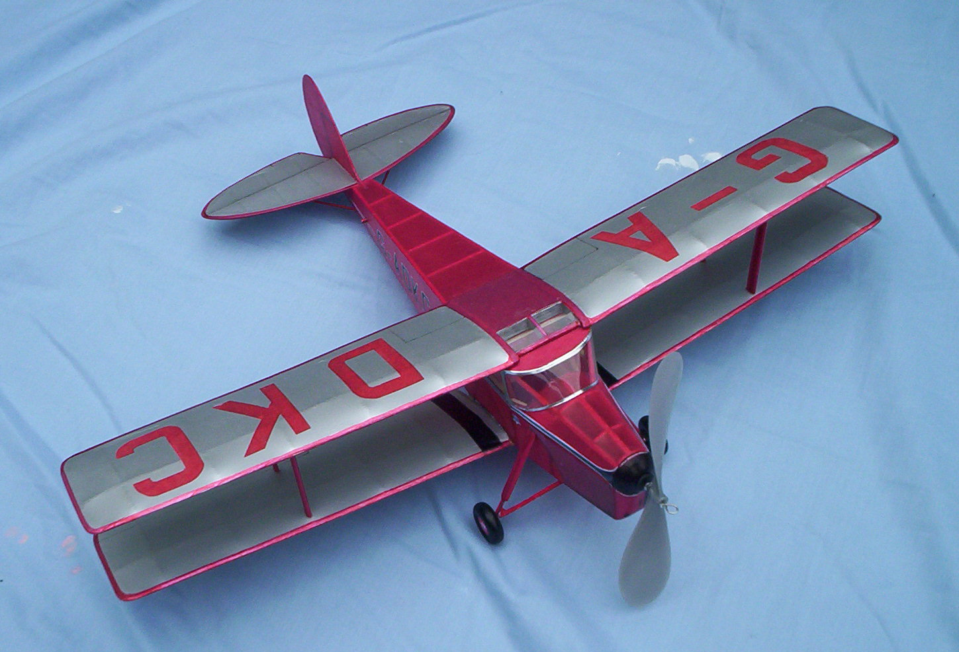
This class has evolved somewhat since its beginnings and continues have a good entry. Originally this class was for rubber power kit models only, hence it is called Kit Scale, but entry criteria has been extended to include any rubber powered scale model aeroplane. There is no static judging but the model must be recognisable as a scale model. There is no flight judging for realism either, as the aim of the competition is to fly the model for a predetermined precision time, usually 30 seconds, not unlike the Bowden type of contest. 3 flights that score over or under the target time in seconds are added up and the lowest score wins. The simplest model can compete with the open class type on equal ground. All you have to do is make 3 flights of 30 seconds. Sounds simple doesn’t it.

FF7 Eddie Riding Competition
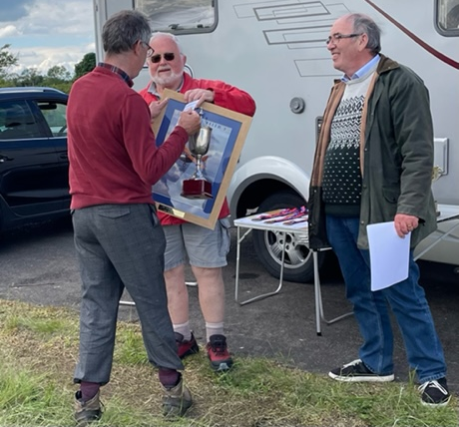
Bill Dennis awarded the spoils at the Eddie Riding contest from Chris Allen STC Chairperson.
This class has two elements that make up the overall competition.
Eddie Riding Open Competition
The first element is an Open Scale competition flown to the current BMFA Scale Outdoor FF Open rules for both static and flight judging. Classes FF1, FF2 and FF3.
Eddie Riding Designs Flying Only Competition
The second element is run to FF5 Scale Free Flight Outdoor Flying Only class which celebrates the designs of E J Riding who was a major contributor to the development of Free Flight Scale in the UK.

