**Scale Free Flight Brief 97 June 2025**

**SAM35 Retro fest**

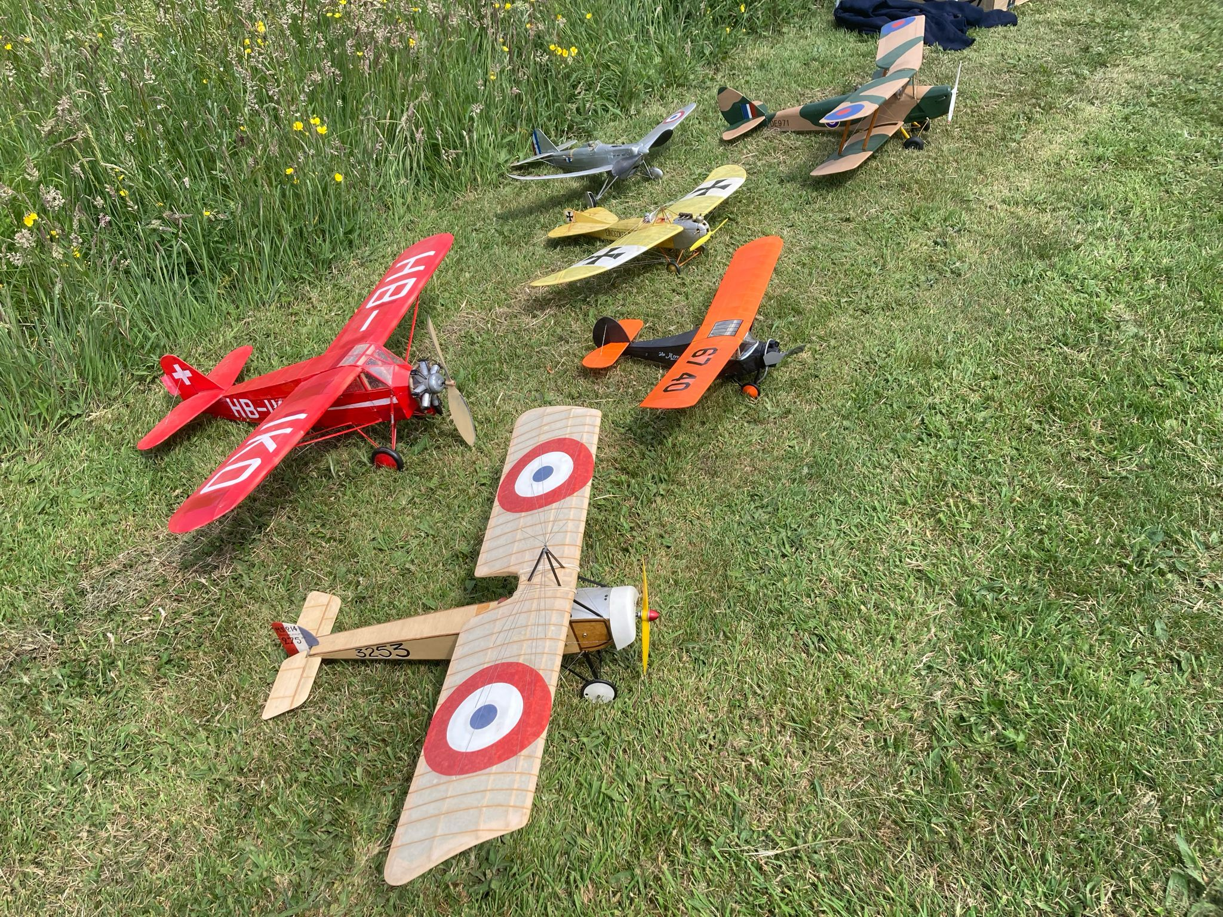

Photo Charlie Jeffreys  
Just a few observations about this event as reports will appear in the Aeromodeller by our scribe Pete Fardell as well as other media.  
Saturday was a complete blowout and the eagerly awaited Scale RC Assist contest did not happen. Nothing we can do about the wind and my efforts on the runway playing King Canute did not influence the wind one iota.  
Sunday had a good entry in Scale Free Flight and we did well in the 10+mph winds. The grass was up to our waists in places and saved any damage from horrible arrivals. The long grass gave us a challenge as the wandering lost model brigade meandered up and down Thanks to Monz for being best spotter.  
It was a good shout despite the wind and I was glad a contest was manageable given that the last four events were not run due to the wind speeds being well in access of doable.

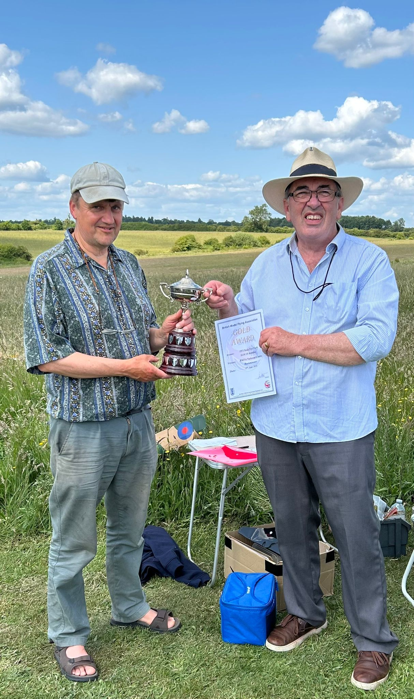

The “face puling” contest prize was photoed by Paul Rich. Scale Winner Pete Fardell.

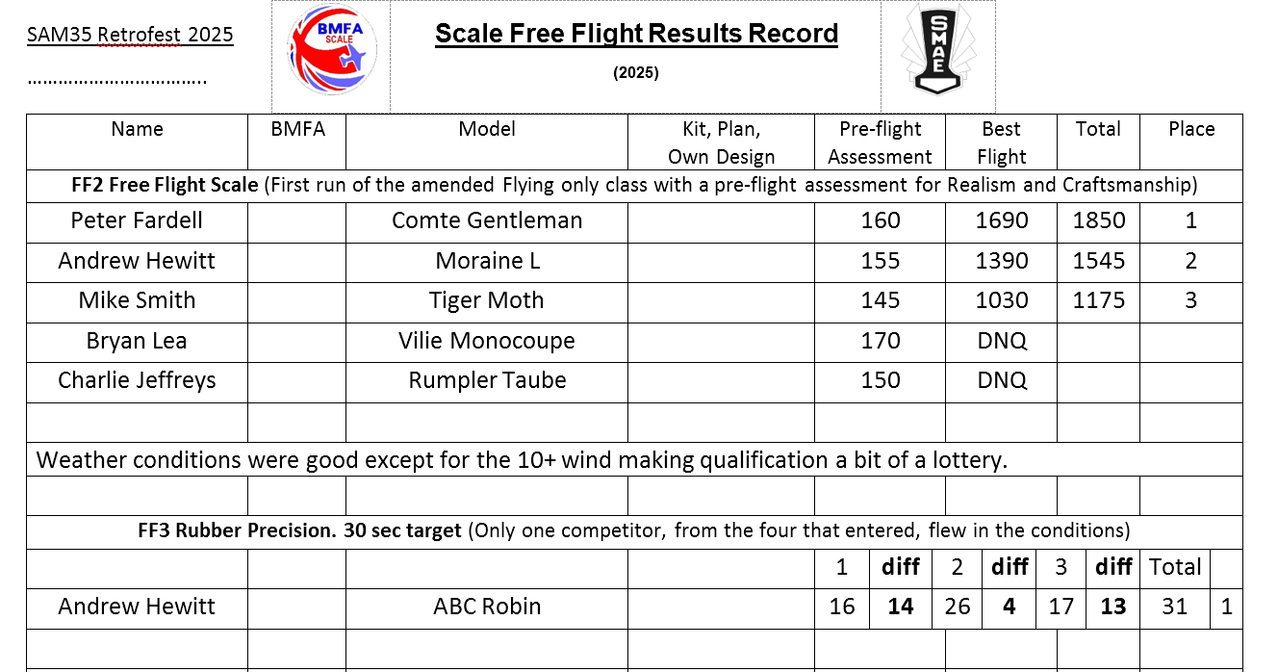

**The Welsh Event**

Good News.  
Martin Pike has been in touch and informs me that he will run another Welsh May Event next year similar to the inaugural event that he organised last May. So, pencil in the date. 23rd 24th 25th May 2026.

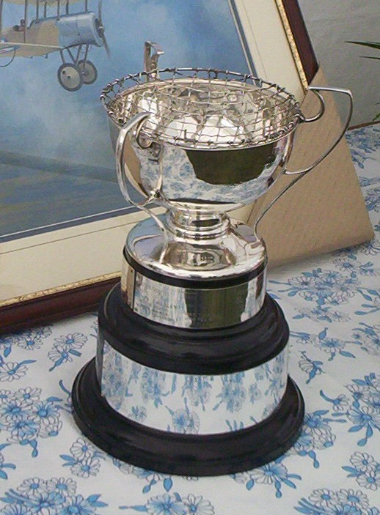**Eddie Riding Contest**

Our next Scale Free Flight event is one of the two major contests for Scale Free Flight year. The EJR contest (FF2 Rules). It will be run at the Festival of Scale meeting at Buckminster on Saturday 28th. The contest will be flown once the RC boys are finished at 5.00. There will be no rush as the evening will be long and will probably be governed by how hungry we become.  
Lots of trophies to be won as well as the EJR Memorial Trophy rose bowl.

Just a Fiver to cover costs. Bargain!

See you there.

Mike