**Scale Free Flight Brief 98 July 2025**

**Eddie Riding Contest**

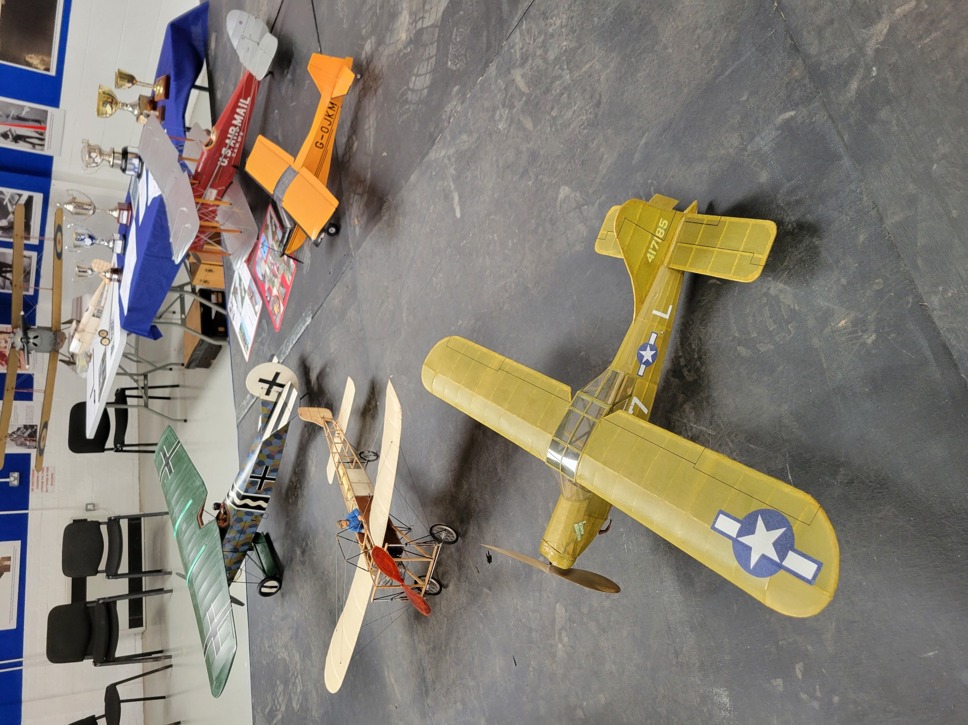

Look out for the full report in Aeromodeller by Pete Fardell.

We advertised to run the event on the Saturday of the Festival of Scale at Buckminster but the wind strength was way over what is acceptable even for scale r/c. However, the Sunday weather and wind were just perfect and the event was run from 5.00 after the radio scale had finished.  
The late notice of day change resulted in a low turn out and only two of us competed. We went “Double Bubble” and contested two models each.  
With the near flat calm and the field covered in a cushion of dry hay we had a very good contest.

Thanks to the onlookers that made the effort to come along and support us.

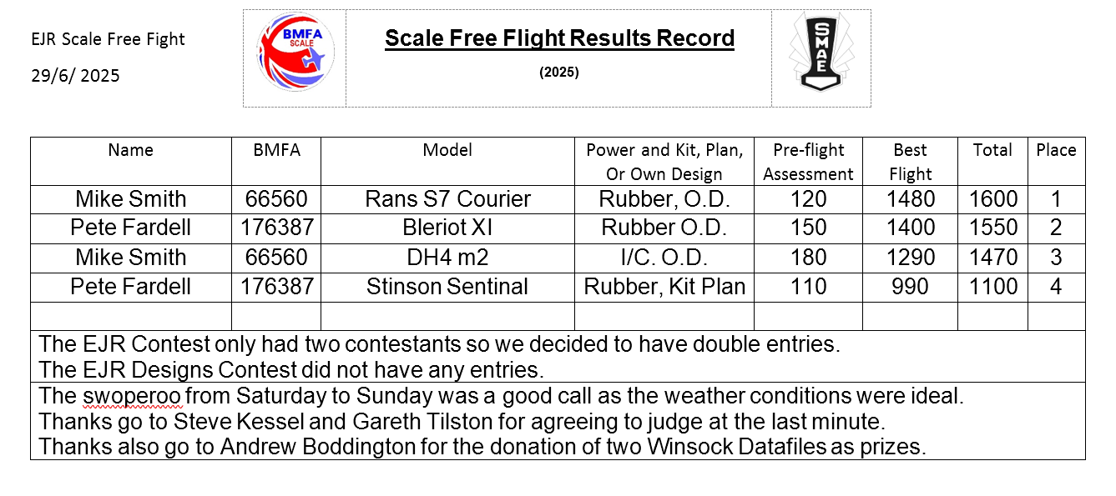

I believe this may be the first time a rubber powered model has won the EJR Memorial Trophy. Does anyone out there know differently?

There are a total of seven trophies for this event so well worth having a go for next season.

The prestigious Eddie Riding Memorial Rose Bowl is awarded for the top scoring model of the BMFA FF2 Scale Free Flight contest.  
There are then six other trophies that are awarded for different powered / type models.

I/C, Rubber, Co2/Electric, Ducted Fan, Reaction Motor (e.g. Jetex) and Multi Engine models.  
There is also a separate contest and trophy for a model from the range of models designed by Eddie Riding. I am considering a change in the rules to include these in the main contest so the trophy is still awarded to the top EJR design. What do you think? There will only be one contest (instead of the currant two) and the appropriate trophies awarded. If there is only one entry in any particular type / power of model then, as long as that model qualifies, then you win the appropriate trophy.

Something for everyone just about, at any level.  
Please consider having a go. There is always someone to talk to if you need guidance.

Thinking outside the box we could run an Assisted Free Flight contest alongside the EJR.

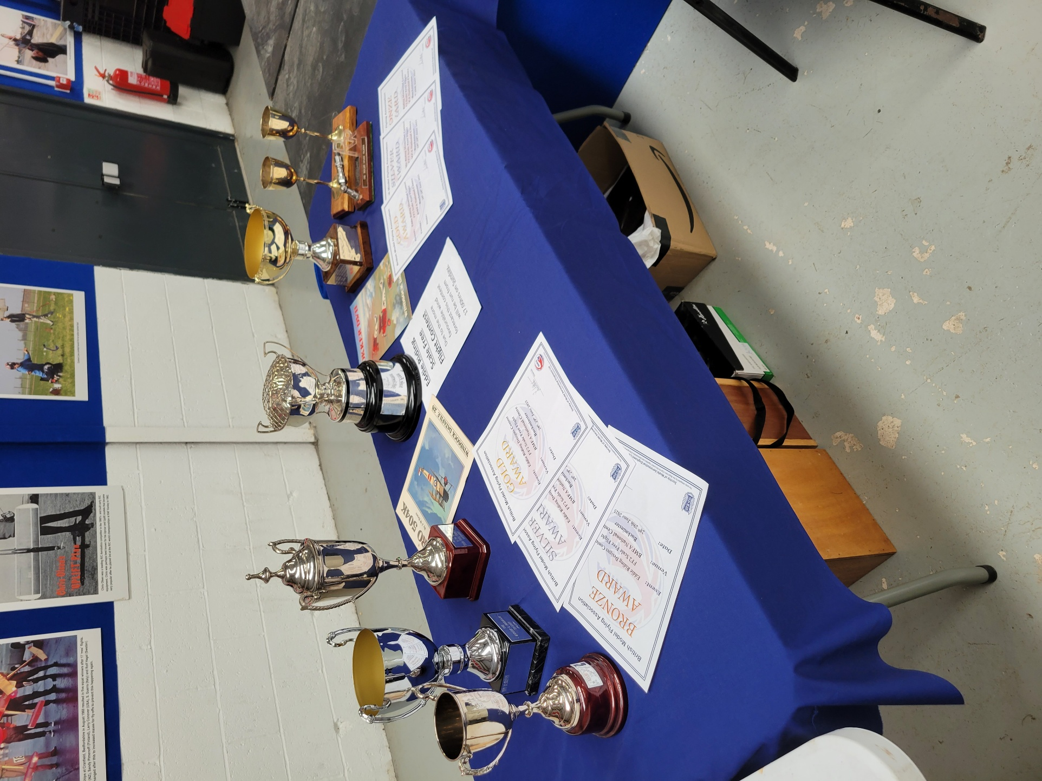

**The Next Contest**

**Saturday 12th July Oxford MFC Scale Fly-In  
Port Meadow****, Godstow Car Park, Godstow Rd, Wolvercote, Oxford OX2 8PE BMFA  
New. It is possible that there are now car parking charges.  
Flying Only (OMFC Rules)  
Scale rubber duration (max span 36" monoplanes, 30" multi-wing)  
Hi-start Scale Glider  
Frog senior  
9:30am start. comps to finish by 2pm free to fly all day if you wish (I/C engines 10am - sunset)  
The event is open to BMFA members who will become OMFC members for the day.  
Details are to be found on** [**https://oxfordmfc.bmfa.club**](https://oxfordmfc.bmfa.club)

**Scale Free Flight WhatsApp**

If you would like to join our group please email me with your mobile phone number.

Mike