Scale Free Flight Brief No: 33 August 2022
Trade secrets are hard earnt but here is one that I will share.
If you have working rigging on your model, then will know how annoying it is to find elastic bands that are small enough.
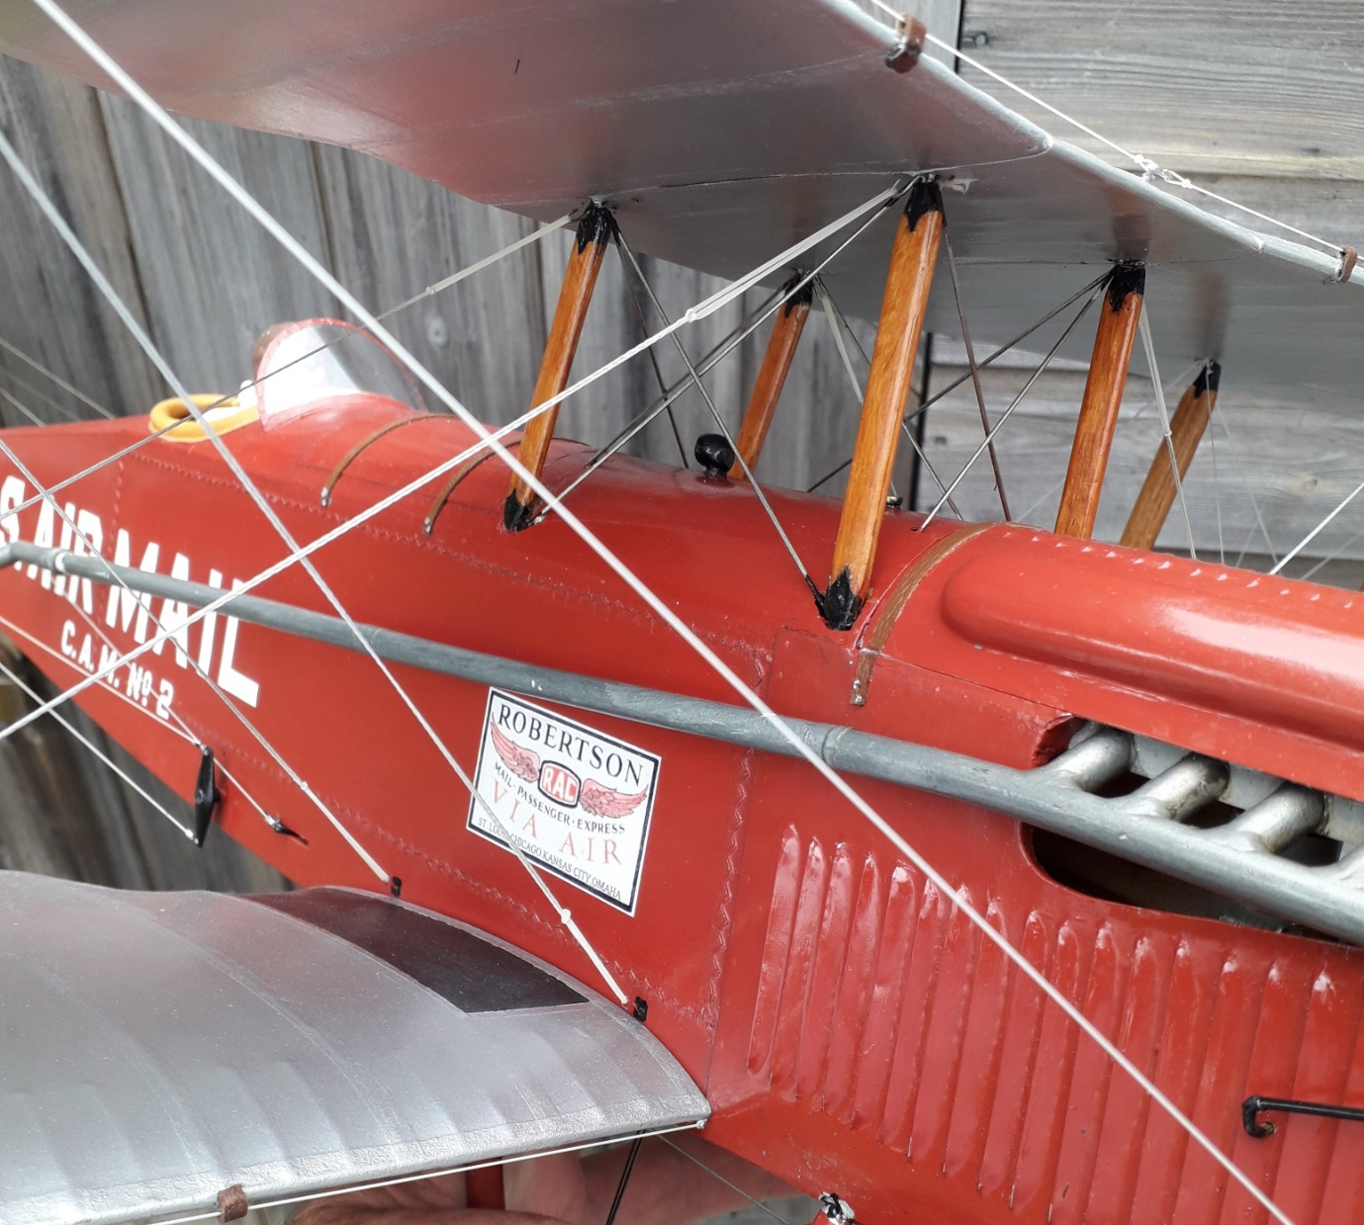
My DH4 is a bit of a cat’s cradle, rigging wise, but the elastic bands I use are unobtrusive and match for colour, near enough. The “wires” are fishing braid, Silver, 36lb breaking strain. Very strong, thin and easy to replace. The control and drag “wires” are beading elastic. .5mm silver.
I use dental bands, the type that tension teeth braces. They come in many sizes and weights so there are plenty of options for the size and type of model you have.
The DH4 uses ¼ inch diameter by 6.5 oz tension. The wing rigging wires are doubled so that the bands can be fitted and replaced easily. A visit to a well know auction site will give you more info.
After lots of trial and error I find that the standard elastic type work well and last. The Latex free type work but only last a few days.
As you may know there was no competition for Free Flight at the Nat’s but we did manage to pinch a half hour last thing on Saturday when the wind died down. Apart from that it was far too windy 3 days on the trot
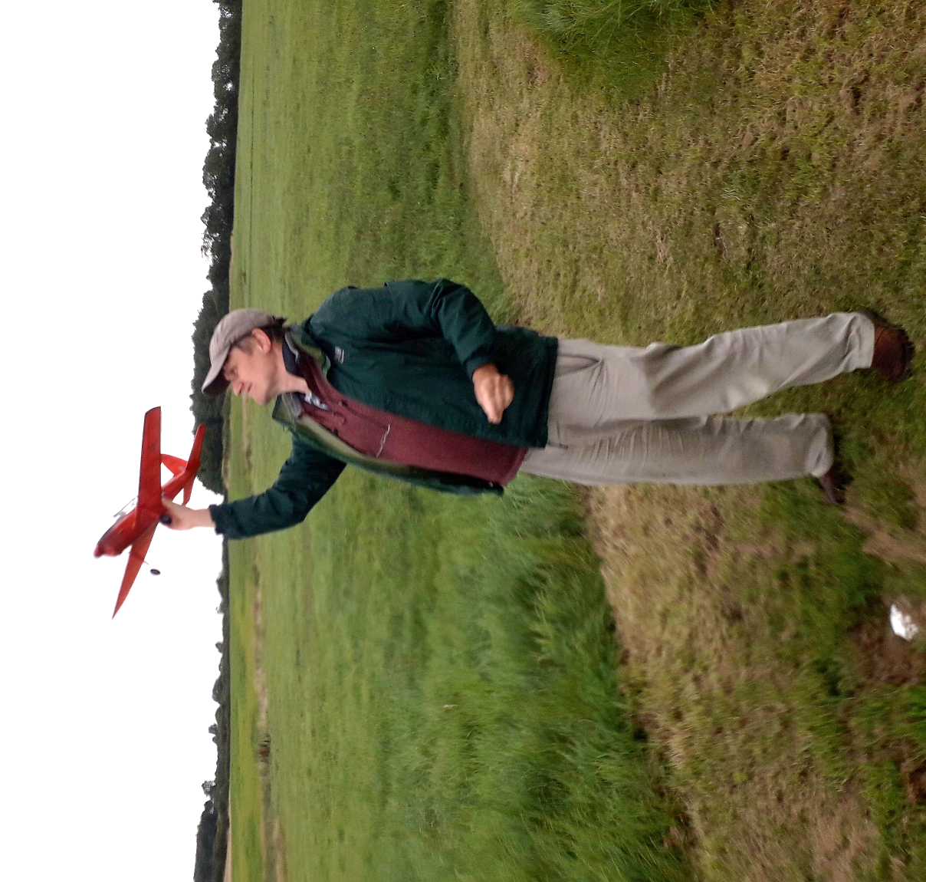
Pete Fardell’s Royal Chipmunk in the gathering gloom. Nice flyer.
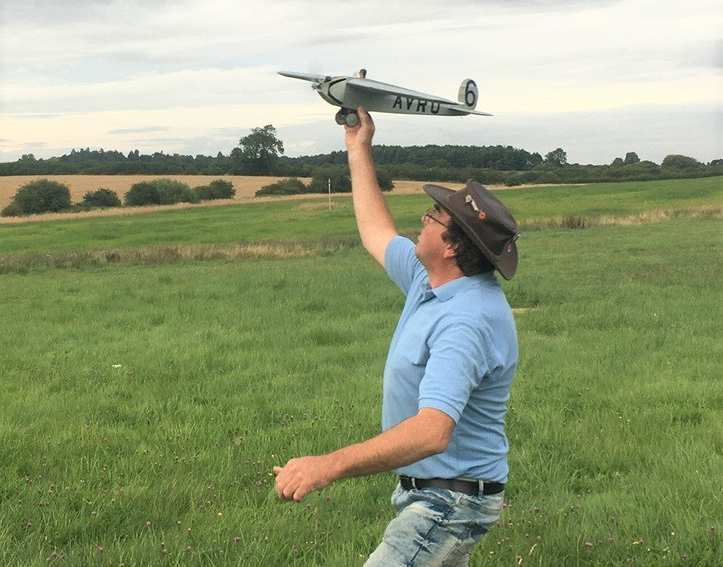
Philip Smith launching his Avro 560. It is proving difficult to trim. It will need to have some dihedral cheated in and the engine, a PAW .5, worked on to get it consistent.

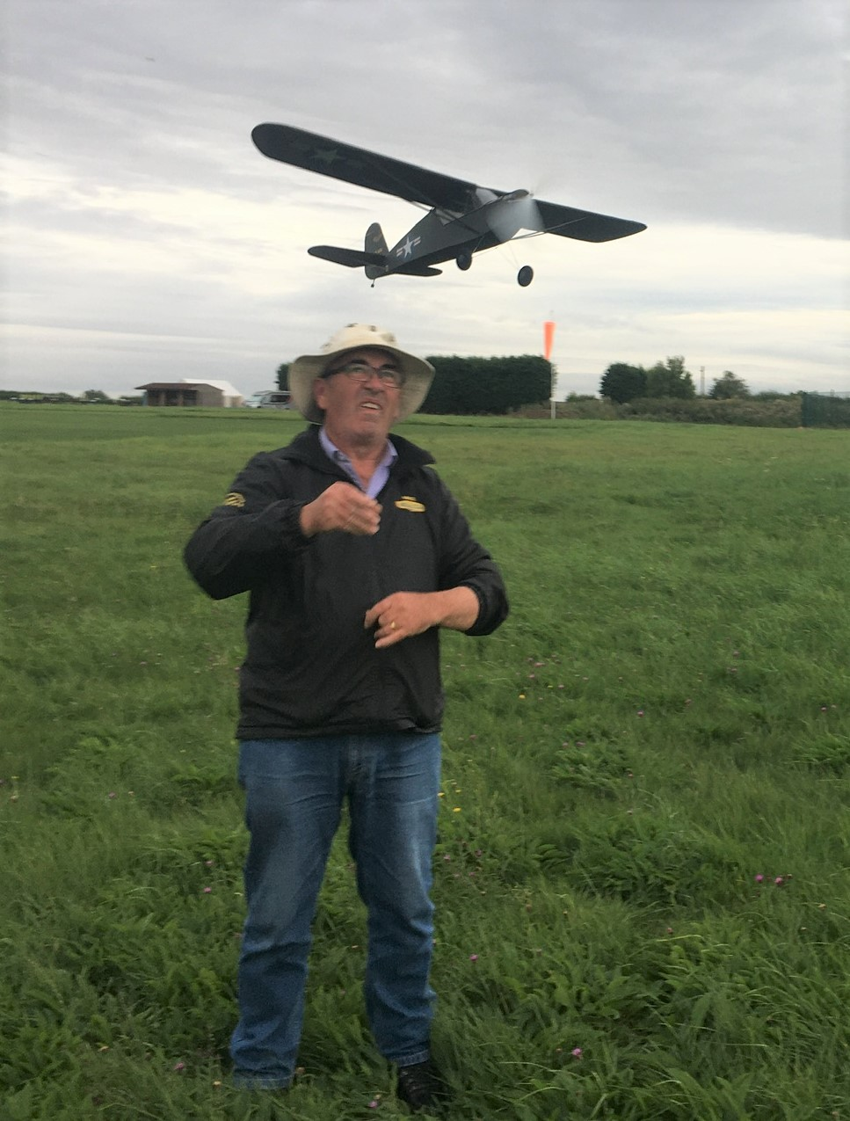
Pete Fardell caught me just right with this shot. I do not look very confident but the model flew well.
I am conducting a BMFA Outdoor Scale Free Flight rules consultation and it is proving a bit tricky to please all the people all the time. “Stupid Boy” as the Dads Army line goes. Generally, very positive though. Fingers crossed. If you want to be involved, email me.
That’s it for now.
Mike

