Scale Free Flight Brief No 34. September 2021
Orthodontic bands
With reference to Brief 33 Mike Woodhouse can supply a variety of orthodontic bands. See his website at https://www.freeflightsupplies.co.uk/index.php/products/sundry-field-equipment
Lodge farm Sunday 5th September.
What a fantastic day flying scale free flight models. Organised by Ivan and Rita Taylor, entirely at their own expense, we had a series of competitions to “Ivan’s rules” that promoted very informal rivalry. The number of entries for classes I/C Power and Electric was not high even with the 20+ attendees but it soon became obvious, that for most of us present, this was the first occasion to use a large space and get the new and old models trimmed as they were not in competition fettle. Rubber Kit Scale/Precision was well supported.
A slight breeze to start with and it built up a little in the early afternoon and then almost flat calm from around four o’clock. By this time most of us were exhausted and retied to Ivan’s “Head Office” for drinks and a slice or two of Albert Ball Mum’s fruit cake or Banana cake and brownies. We never had it so good.
Thanks must go to a lot of people who put a lot of work in to make the meeting successful. Not least was the liaison carried out by Walter Hodkinson on our behalf with the farmer that generously allowed us to use the field.
Even the sheep on site played their part and were well behaved and gave us plenty of space.
Andrew Boddington, AM Editor, joined in the flying and was kind enough to donate prizes and a year’s subscription to Aeromodeller. Look out for his report in the Aeromodeller in due course.
Pete Fardell’s video of the day. See https://youtu.be/oAwVrQDxIJ0
Chris Brainwood video. https://youtu.be/y_iFd9yj_iU
Hip Pocket Reports and a great range of photos from Pete and Chris. https://www.hippocketaeronautics.com/hpa_forum/index.php?topic=26201.0
Should anyone wish to use the site please contact Walter Hodkinson on 07502 939 234 to establish if the site is available as it is a working farm site with livestock and a hay crop.
The mood was very positive and, I am sure, the catalyst for the first of many successful meetings now that the constraints of covid have relaxed and we are allowed to participate freely. I have started work on the calendar for next year and, the “Lurgy” permitting, it could be a busy one.
The reserve date that was posted for the above meeting is now on the calendar as a confirmed meeting. Weather and all the other constraints permitting.
Rules Update
The consultation for the rules update is nearing completion. There are just a few minor issues to sort, mainly from the safety aspect. When complete, this rules reset will be put forward to the STC for consideration.
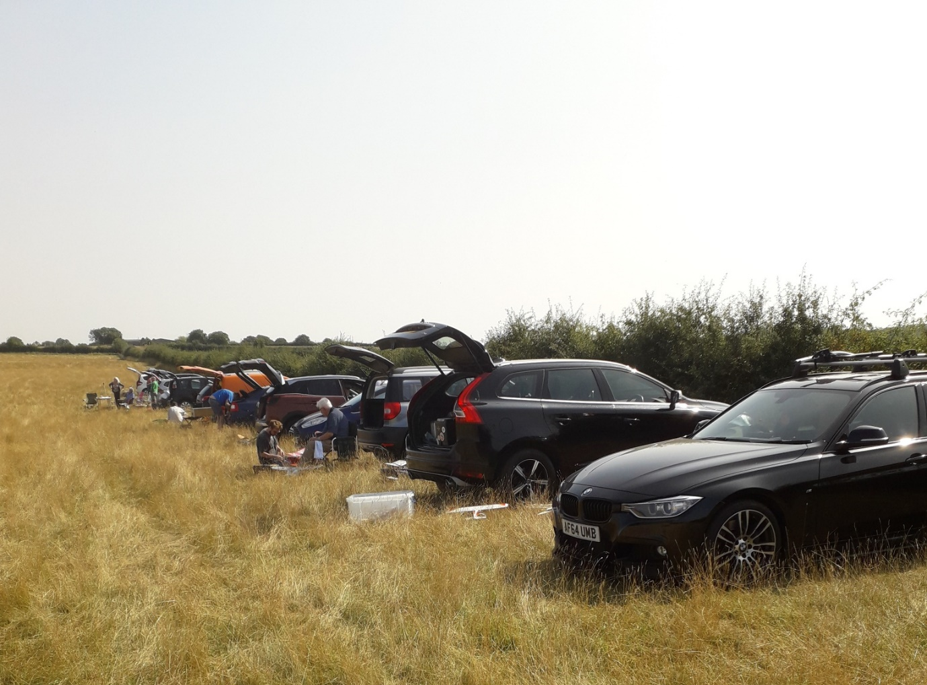A row of cars to indicate the turn-out at Lodge. More arrived after the photo was taken.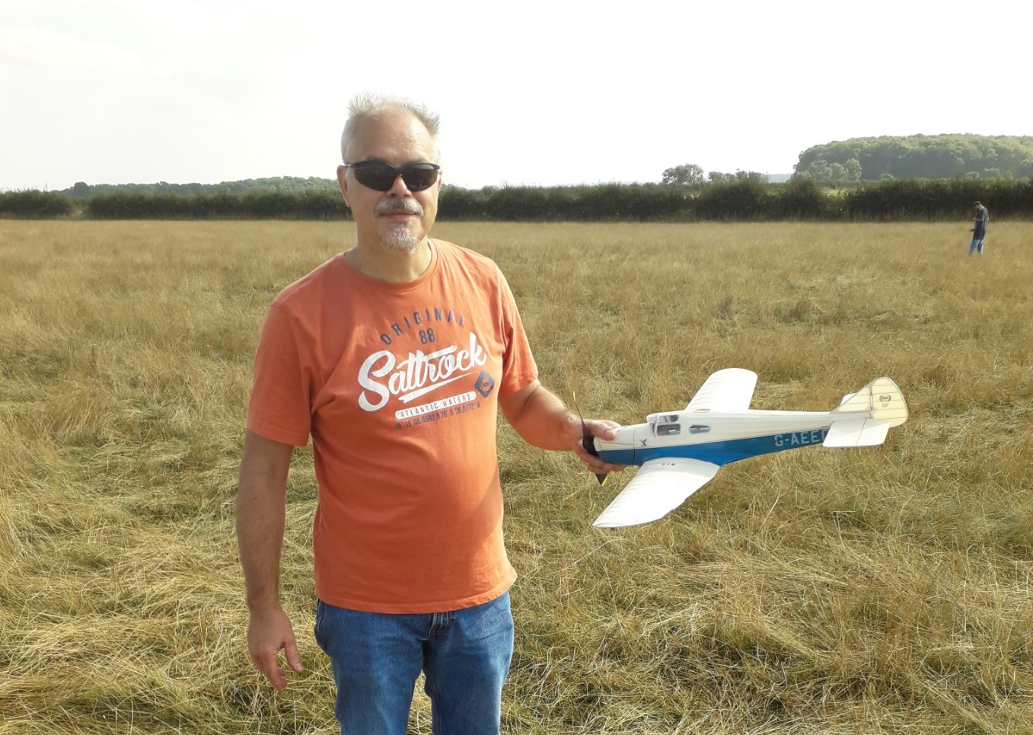
Cool dude, Chris Brainwood with one of the boot-full of new “covid” models. A beautifully finished Miles Falcon. Just look at the model cushioning grass and not a sheep in sight.
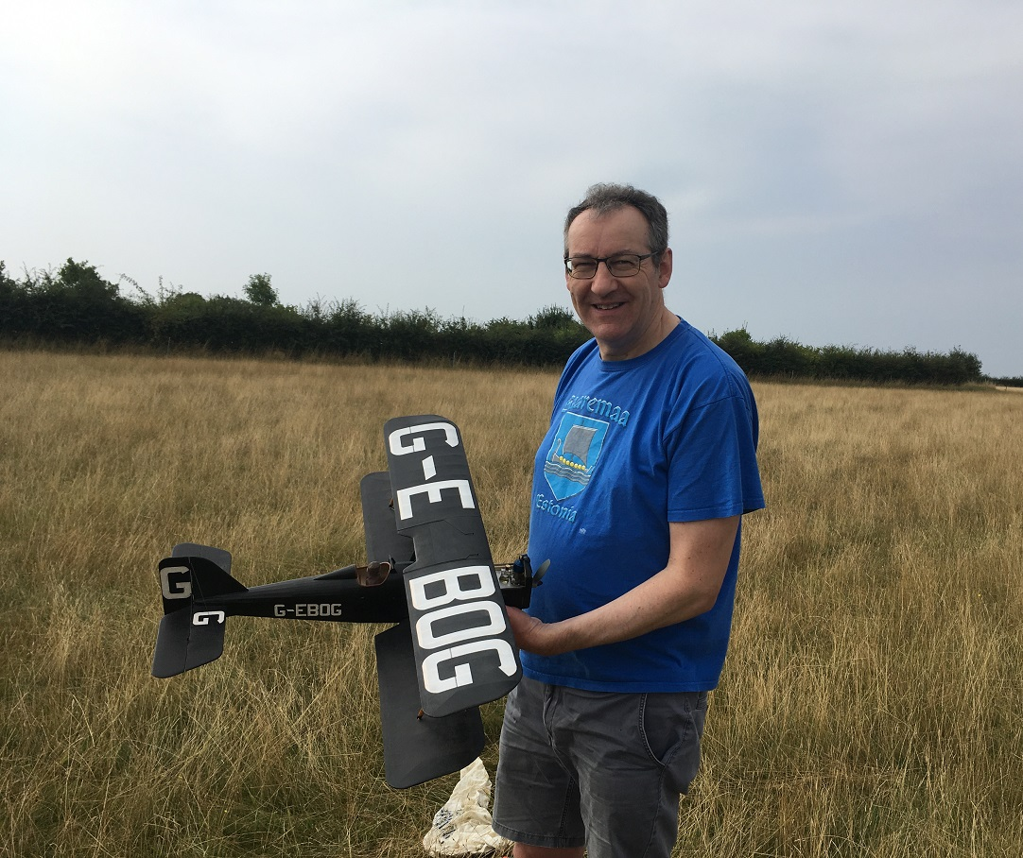
Good to see Mike Kelsey back with his SE5a. There aren’t “any” at Lodge Farm.
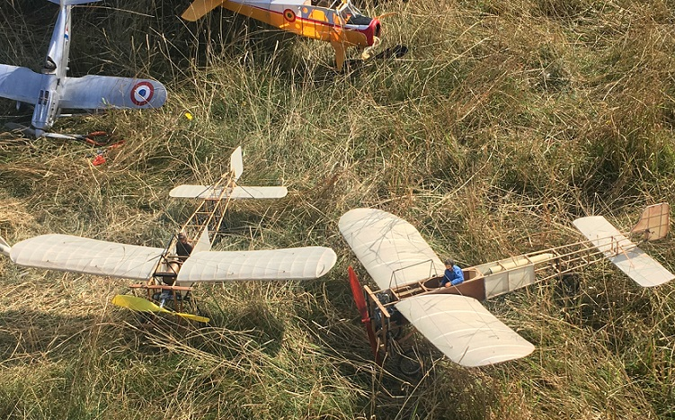
Bleriot ensemble by Pete Fardell and the exploding prop version by Chris Brainwood

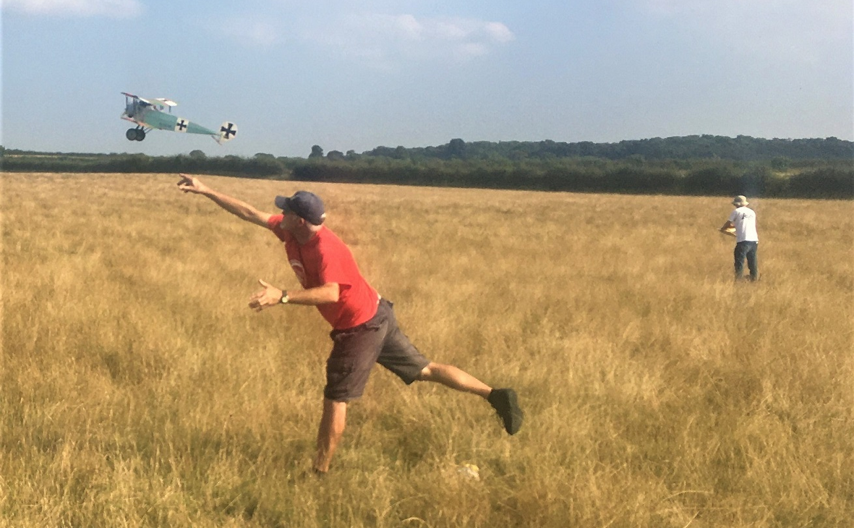
The athlete amongst us. Andrew Hewitt trimming his Fokker D? something.
Pretty model with nice metal turning and no dihedral.
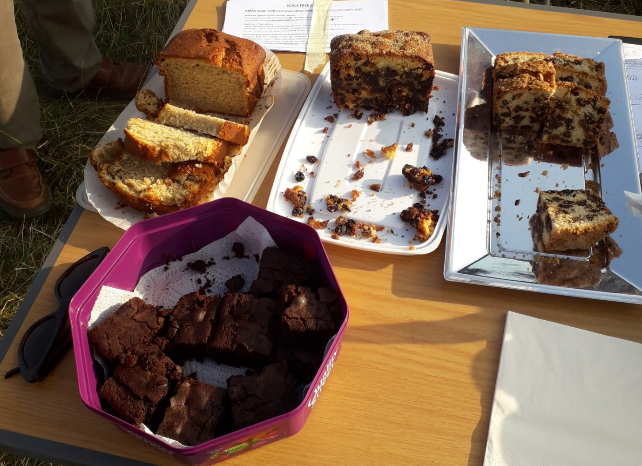
The important part of the day. Albert Ball Mum’s cake, Banana Cake and Brownies finely crafted by Rita with my effort on the right. Serviettes for the posh people.

