Scale Free Flight Brief No 35. September 2021
Regrettably I could not make it to the Peterborough Flying Aces and I am indebted to Pete Fardell for the following overview of the meeting.

Scale at Peterborough MFC ‘Flying Aces’ 2021
Superb calm, warm conditions for the Peterborough Club’s 28th(!!) ‘Flying Aces’ meeting at Ferry Meadows on Sunday 12 Sept. This famous, annual jamboree of free flight was VERY well attended (at least 65 cars on the field) and many of those participants, myself included, were flying some of their scale models. There were loads of great flights from a very nice variety of subjects. To name just a few then…
John Bowerman’s Gee Bee sportster peanut flew well; a little gem in its striking blue and yellow scheme. Tony Johnson’s big rubber Nesmith Cougar actually landed and rolled to a stop on the short grass without nosing over. Derek Knight’s EDF Saro and Miles Student jets also flew beautifully and belly landed in long extended skids. Most entertaining! Back in rubber, Mike Stuart’s large Blackburn Shark and big new Consolidated Fleetster were both a joy to behold in flight and Gordon Hannah’s Puss Moth circled sweetly all day. Kevin Wallace gave his venerable electric Bowers Flybaby bipe a (final?) outing and Andy Sephton campaigned his sweet flying little BE2. I took my French duo along (Bleriot XI and Dewoitine 500) and had a ball in the open rubber and Masefield events. Although the grass was very short and unforgiving, with so little breeze and with so many properly pre-trimmed models I saw very few mishaps. Mike Stuart and I did both skirt perilously close to the car line on a couple of flights, but the gods were smiling and all was well. Russ Lister was kept very busy all day judging the scale flights. Big thanks to him, and huge thanks to all the helpers at the club for running yet another wonderful day; especially the main organisers: Brians Waterland and Lever. They’re handing over the Flying Aces reins next year, but what a debt we owe them! Full results will no doubt be on the Peterborough MFC website shortly: https://www.peterboroughmfc.org/index.htm and don’t miss Andrew Boddington’s upcoming event report in Aeromodeller too. Big congrats to all the winners and placers. See you at the next one!

Pete Fardell

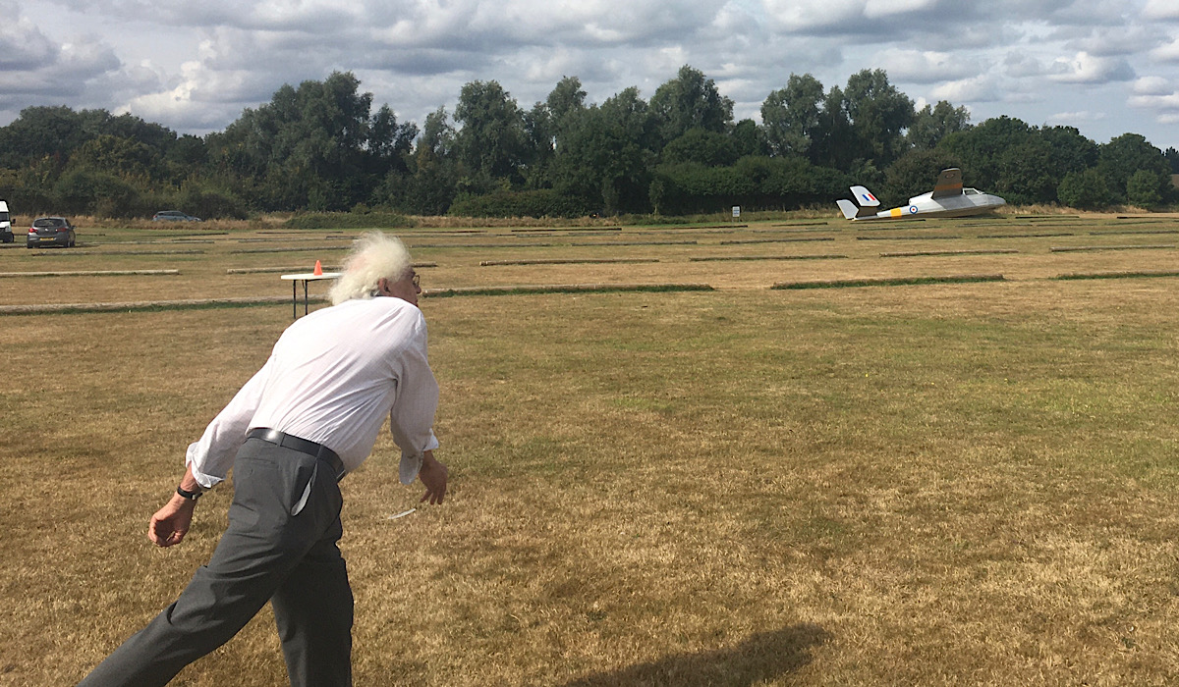
Derek Knight giving his Miles Student big “heave-ho”
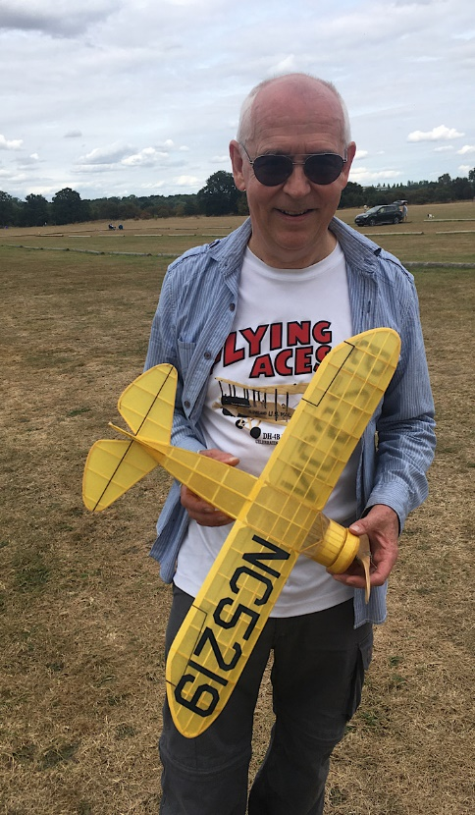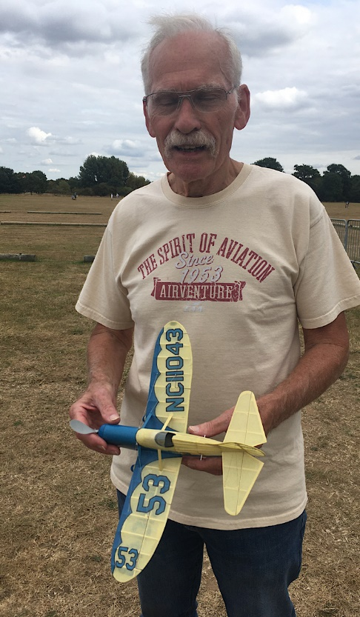
Mike Stuart John Bowerman
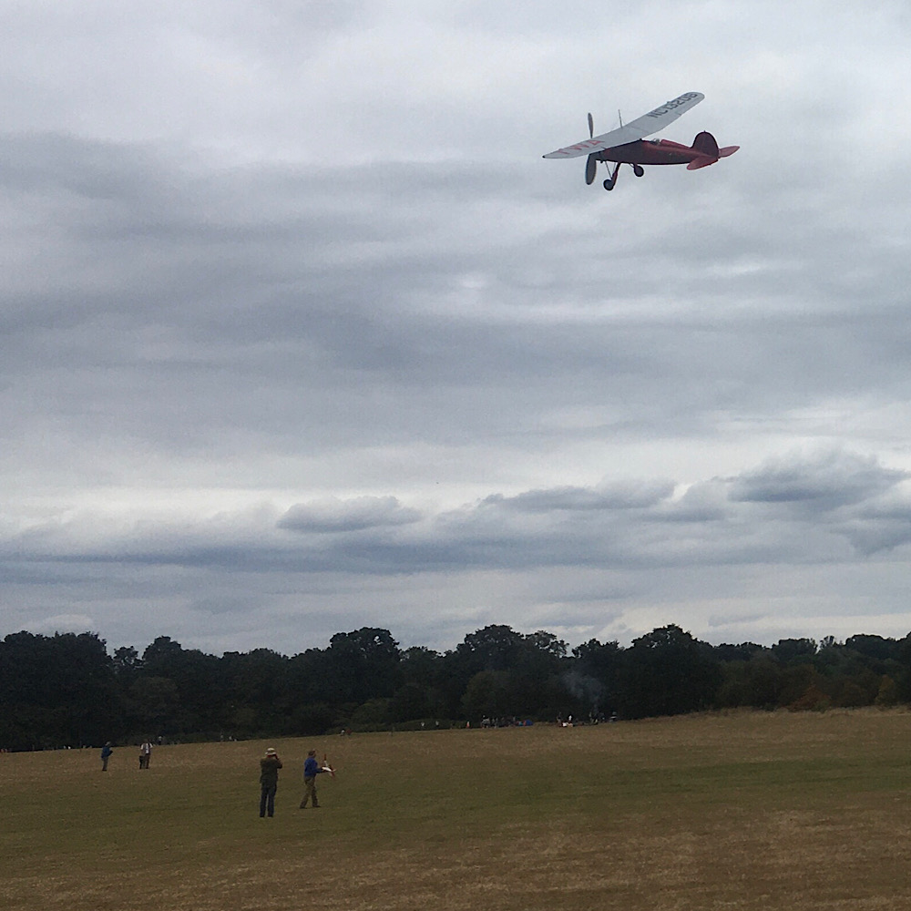
Mike Stuart’s Consolidated Fleetster Mike’s website http://www.ffscale.co.uk/
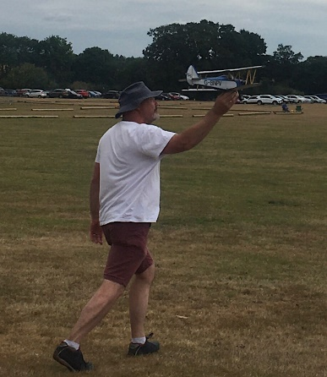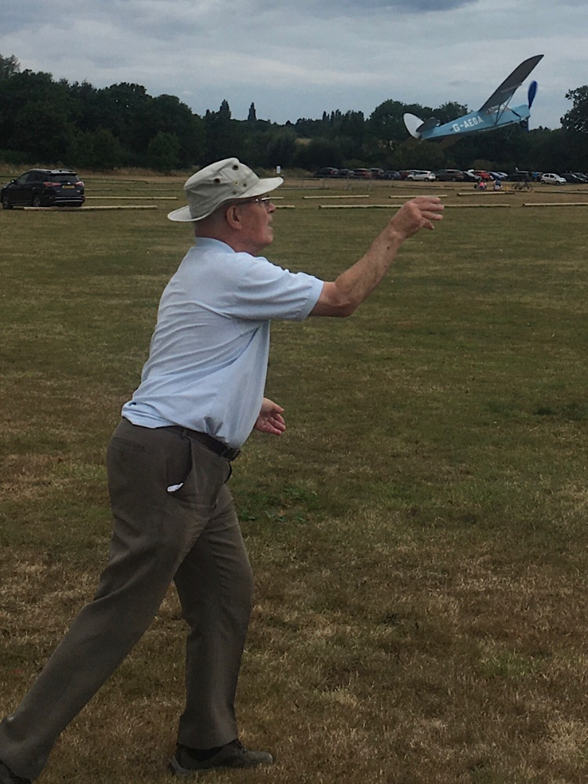
Kevin Wallace with his Bowers Flybaby Gordon Hannah’s Puss Moth

For those of you that are not aware Youtube https://www.youtube.com/ has a lot of Scale Free Flight videos, and in particular two of our participants post a number of videos of the meetings they attend. If you want to receive notifications of these postings you can click on the link and subscribe to their channels and click on the bell and All.
Chris Brainwood https://www.youtube.com/channel/UCi_w36uhLSq2mqarouJPDTA
Pete Fardell https://www.youtube.com/user/PGFardell
Hip Pocket Aeronautics is an excellent site for all sorts of information and a Forum that is very active for Scale Free Flight. Link, https://www.hippocketaeronautics.com/index.htm
If you only sport fly, scale or not, you are welcome to come to any of our meetings and find out what we are up to. We are friendly bunch so do not feel you would be unwelcome. You would be allowed to sport fly at most of our meetings but do contact me first to check.
This email list has almost reached 100 persons so, if you know of anyone not subscribed get them to contact me.
These Briefs are now being posted on the STC website https://scale.bmfa.org/ Click on Latest Scale News. Notifications are automatically sent out to STC subscribers and they will reach approx. 170 persons. Some of these may be duplicates.
My website www.freeflightscale.com has now been modified to include a page for the calendar I send out.
That’s it for now except a reminder that it is Modelair’s Festival of Flight at Old Warden this weekend. Weather forecast indicates a low wind speed. John Ashmole is running a Rubber Bowden on Sunday. Book before in 12.00 Join in. I will attempt to organise an informal scale mass launch before or after the Bowden. First down gets the wooden spoon last down a bottle of wine
Mike Smith.

