Scale Free Flight Brief No.36 September2021
Indoor Free Flight
I have received some info’ From Mike Stuart about dates and meetings.
Six hours of trimming time available on 25th September 2021. 10 am at Bushfield Leisure Centre, Peterborough. It’s a good-sized hall - cost £12. Sport flyers also welcome.
I’ll be there trying to get my new Curtiss SOC Seagull to fly.
Graham Kennedy has offered to come along to go over people’s documentation and give advice on possible improvements.
Scale indoor FF Nats booked for Sunday April 24th 2022 at Wolverhampton University Sports Centre.
Scale Indoor RC Nats on Saturday 23rd April at the same venue.

I.I.F.I. (International Indoor Fly In) may or may not take place on the weekend of November 13th and 14th in Nijmegen, The Netherlands. The organisers are currently getting feedback from potential entrants.

Peterborough Flying Aces.
The results are available at http://peterboroughmfc.org/FA2021Results.htm
Modelair’s Old Warden Festival of Flight 19th September.
This year’s meeting was well attended by the scale fraternity and made a very good impression on the proceedings.
The weather threatened with a light drizzle around mid-day but cleared quickly to give a very good low wind session to the later part of the day.
John Ashmole organised a Rubber Bowden Contest in two classes. A, for high wing and B, for low wing models. Scale models put in a very good show winning both classes, and places, from a very respectable total of 17 entries. Details to follow. Thanks John!
John Ashmole on the score sheet with a queue, ready to fly in the Rubber Bowden.
Mike Smith Organised a fun Scale Rubber Mass Launch. Next time I do this I must write down some details as they happen. The contest was over in a flash of confusion and a few more spotters are needed to keep an eye on the proceedings. A megaphone was useful to “herd the cats” with.
Nine people entered with a wide range of models. I made it quite clear that I expected participants to be honest about who was first down, as I had a little something of an award. First down was Pete Smart and he seemed quite chuffed at the award of a bottle of Old Peculiar Ale and a suitably inscribed wooden spoon. Even Alex Whittaker took photos of the presentation. The last down was the organiser, me, just piping Mike Stuart’s Blackburn Shark by couple of seconds with my Bowden winning Aeronca Defender.
A good bit of quick fun with almost no rules. It will be worth giving it a go at other meetings.
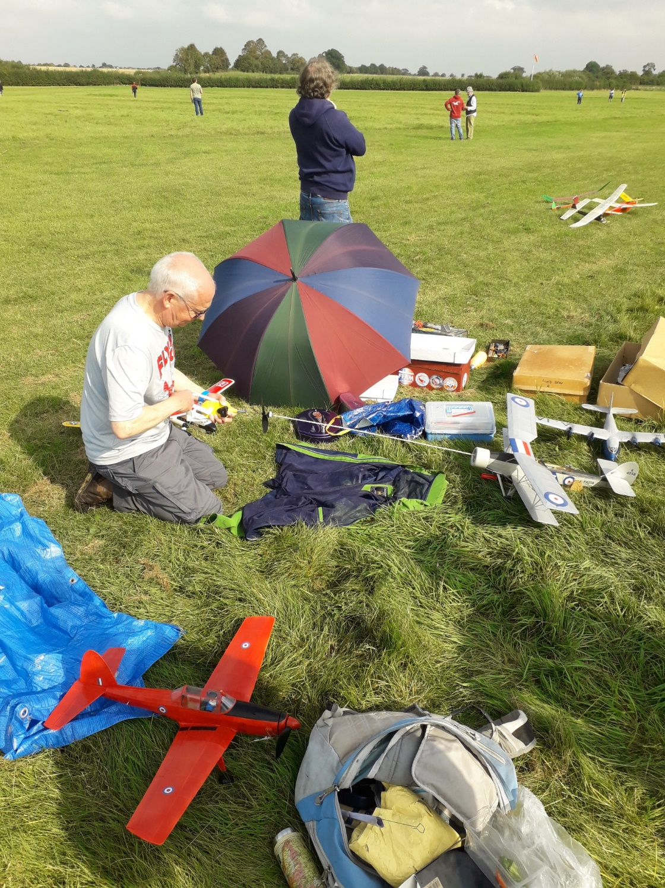
Mike Stuart winding for the Mass Launch with Pete Fardell’s Chipmunk in the foreground
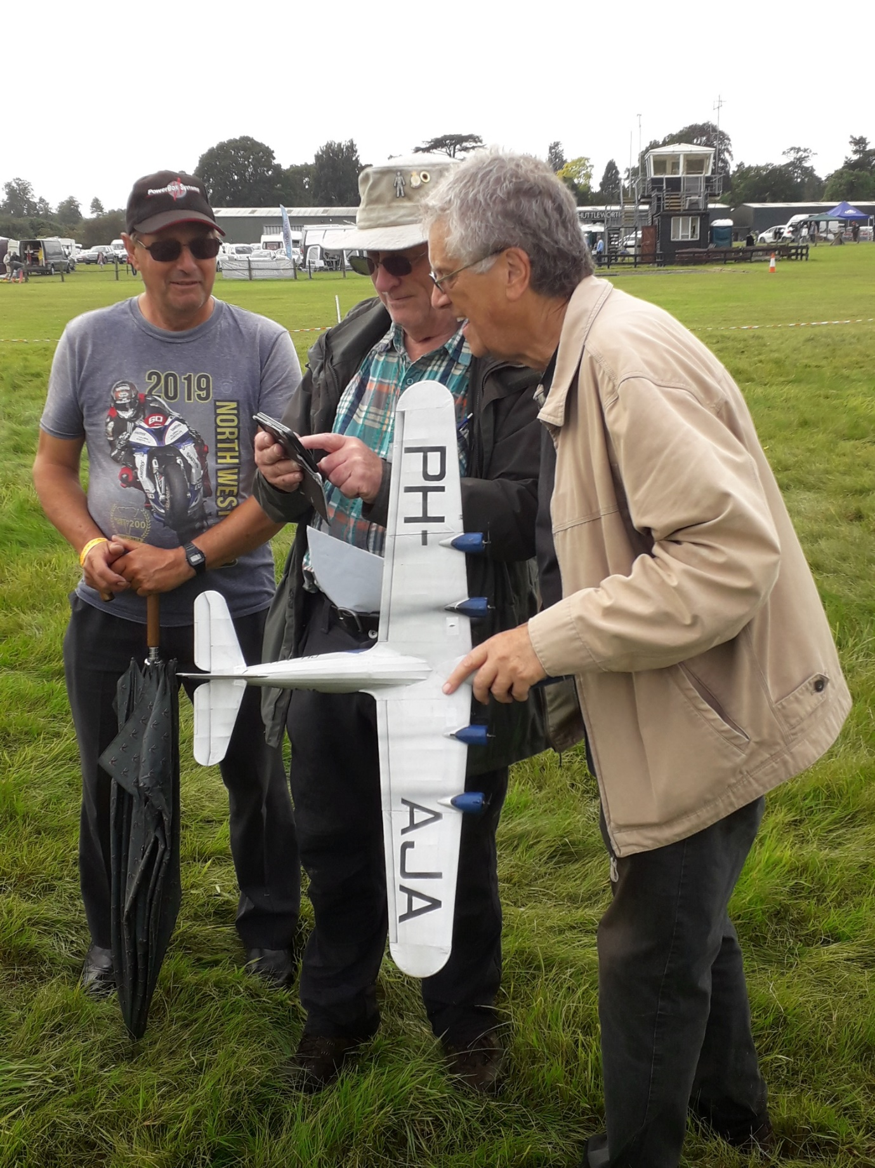
Pete Smart with his fantastic electric x4 Fokker DXX11, Andy Sephton and a gent’ from the Northwest, he has an umbrella, discussing Candid Camera.
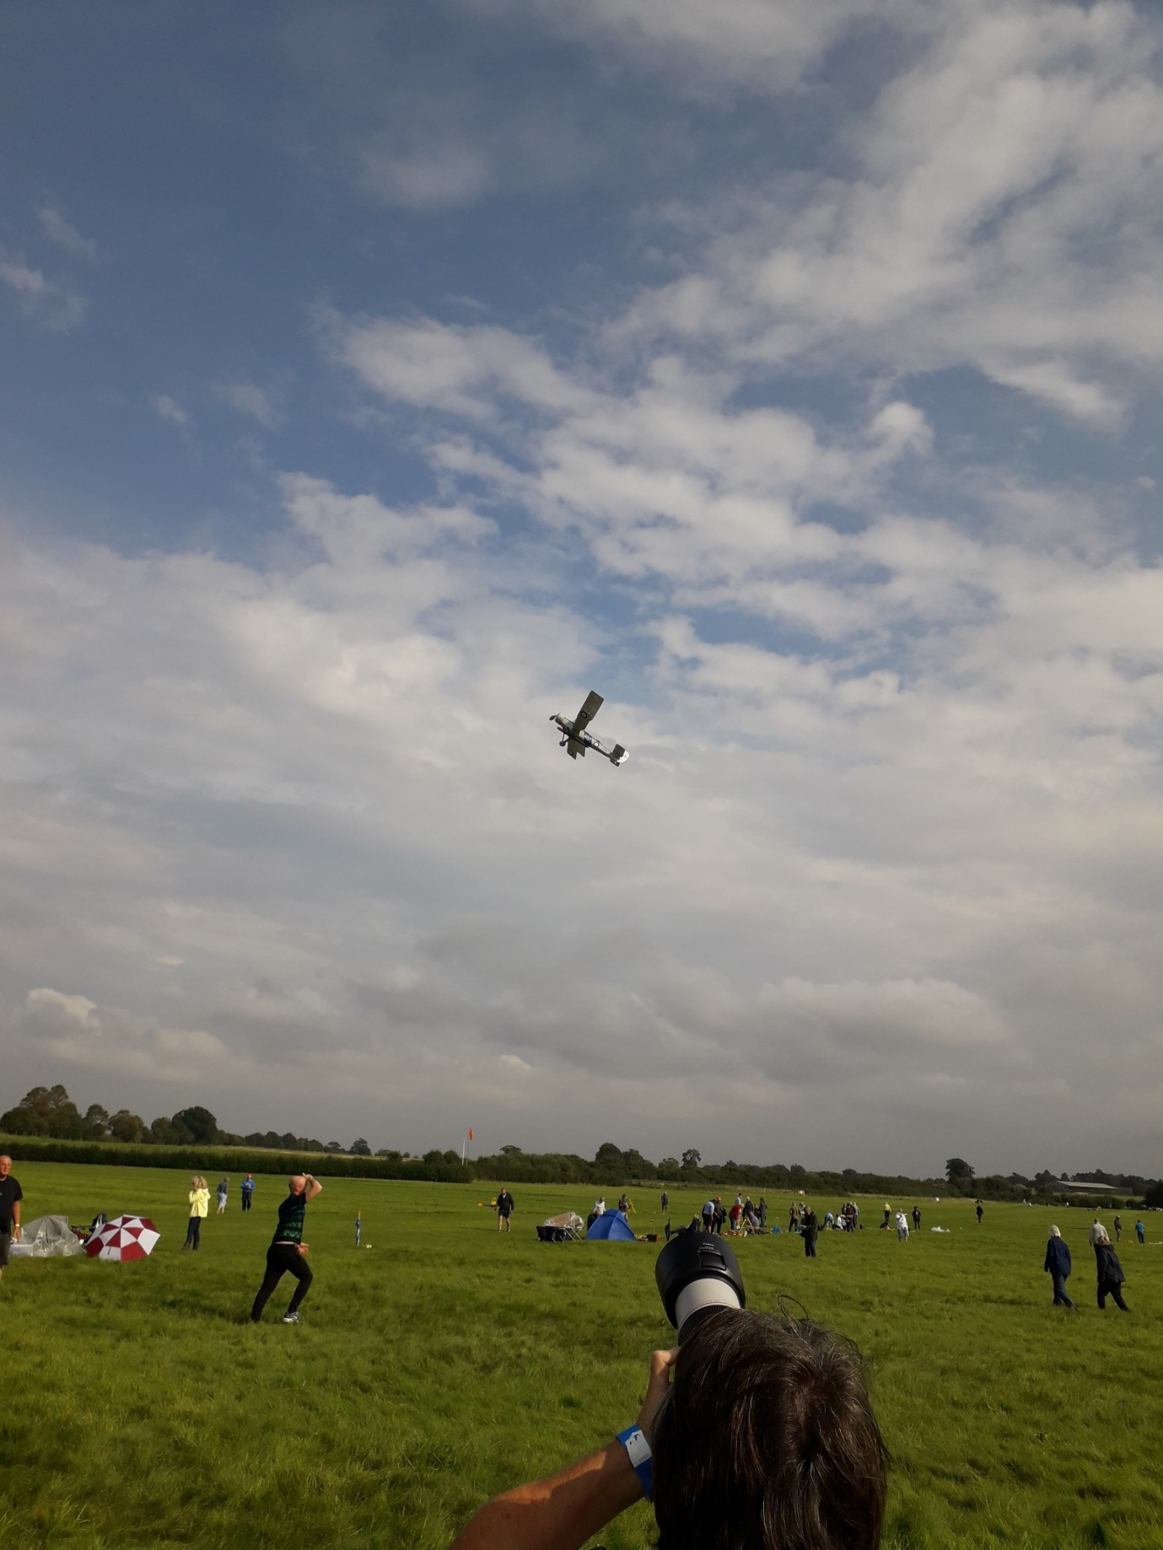
Here is a familiar sight. Alex ”full head of hair” Whittaker with the Blackburn Shark off on another sortie in the blue sky.
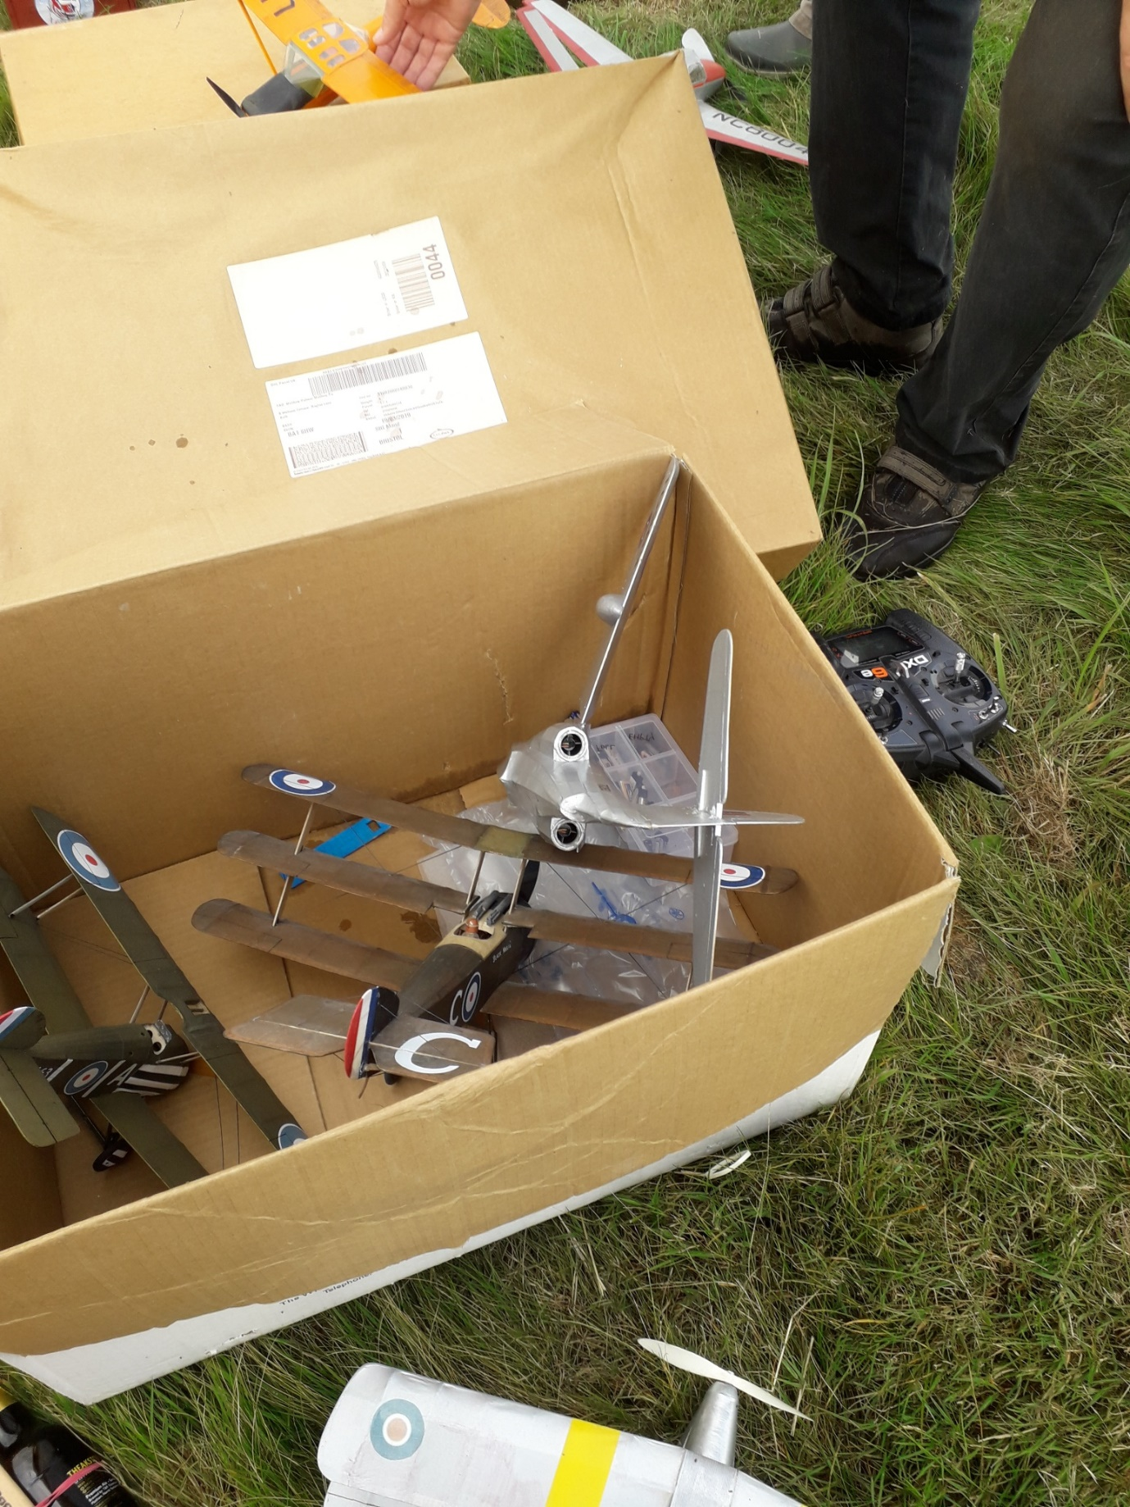
This has got to be the photo of the crash of the day, or season even. Why? The twin electric D/F Saunders Roe was inadvertently launched with only one motor running, it turned and dived in to the right straight into Pete Smart’s Toy box exactly as you see it. This is a fast model and it, and its missing wing, did not touch any other model. No damage at all!!! There was an element of panic by both parties until we realised, we had been very fortunate and used up all of our good luck for the day. Phew! and oh gosh! or words to that effect.
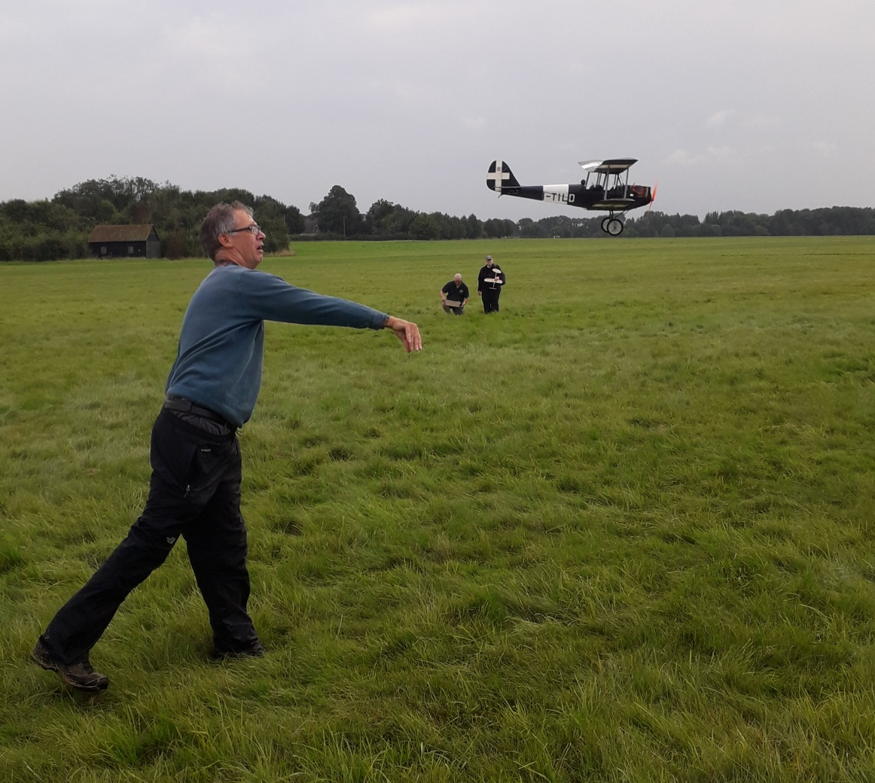
Bill Dennis gets his delightful electric Caproni CA100 away. Light, slow and stable with a very nice presentation that will do very well in Craftsmanship and Realism
That’s it for now.
If you have anything you would like included, please let me know.
Mike.

