Scale Free Flight Brief 38. November 2021

I received an email from Ray and if you are interested in free flight scale & live in the north of England, Ray Hall would like to hear from you.
“Whilst I would not wish to discourage anyone from visiting Buckminster etc, flying sites for trimming have become almost non-existent, in these parts, but there are possibilities & some of you may have suggestions, I also know of possibilities. Please contact me if you are interested”
Ray Hall.
rayhall1939@gmail.com

Buckminster Addendum
In my rush to get the last Brief out I missed a couple of people. Sorry.
Mike Kelsey got the best of the weather on Saturday trying to trim his SE5a. He was frustrated by the lack of power but did manage flights just enough power to assess the model. The conclusion was to try different propellers on the Redfin .5cc engine. We will see what happens when he tries again.
Another Scale modeller present was Gareth Tilston. He also joined in on Sunday and entered the Rubber Ratio contest but was unlucky enough to break a propeller. Thanks for doing the timing Gareth.

Did anyone notice the blooper? I stated that my GB3 model had 8ozs of rubber in it. I would not be strong enough to wind it. I should have put 80gms (3ozs), Oops.

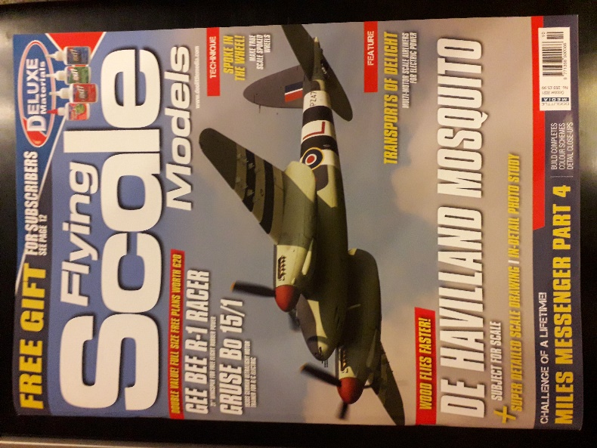

Flying Scale Models Magazine
I notice this magazine is running Andrew Hewitt’s series, Surviving Free Flight Scale.
A very interesting series of how to go about building and flying our scale models for beginners and experienced scale modelers alike. Lots of other articles that are useful.
Free plans.
Very recommended.
The series started in the October edition.
Back issues available.

From Andrew Hewitt
Hello Mike,
I must share this with all the readership, too good to keep shtum. This is my 1/12 scale Fokker Ei nose. I have covered it with silver wrapping paper from my post office, then put the squiggles on with a silver ink pen, dead easy, quick and very convincing for smaller scales. I have not done the cowl yet. Could be good for many different front ends?
Regards,
Andrew
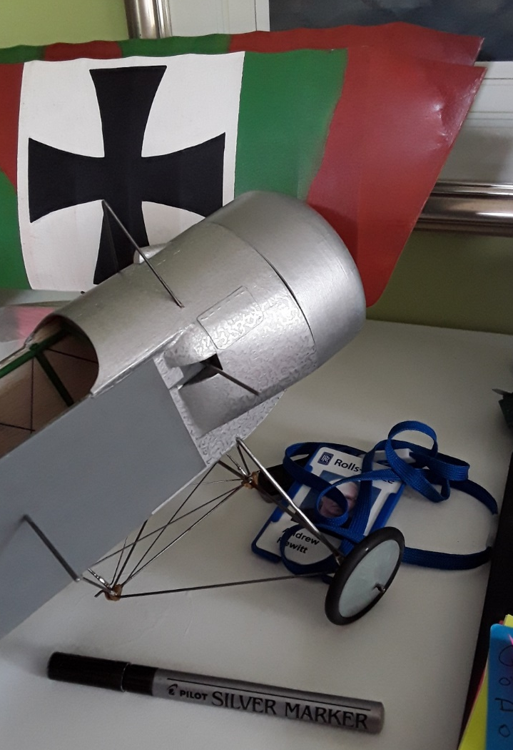

I will be in touch.

Mike Smith

