Scale Free Flight Brief No 40 December 2021
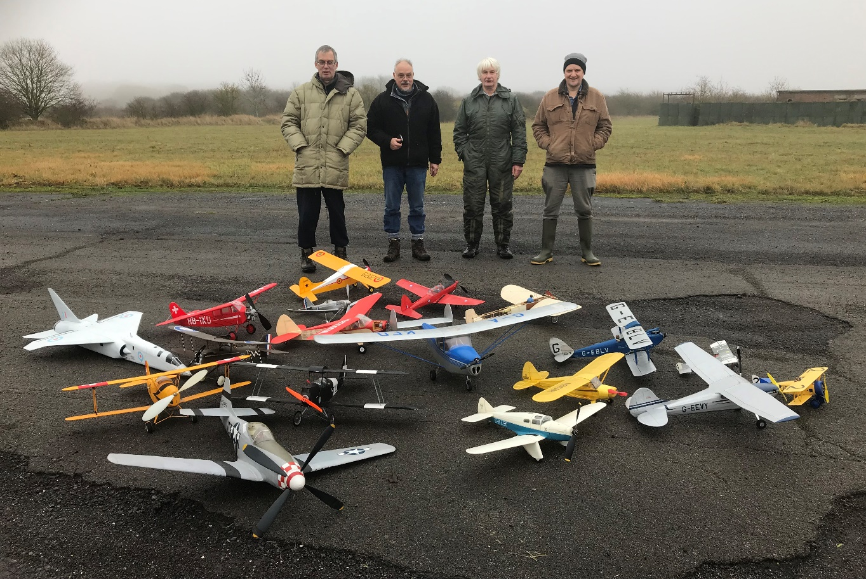
The Luffenham Four + One
Bill Dennis (photographer is Trish) Chris Brainwood, Ivan Taylor and Pete Fardell.
Photo by kind permission of Bill Dennis
Free Flight Scale was asked to make models available for the making of the BMFA 100 celebrations film at RAF North Luffenham.
An impressive collection of eighteen models was assembled by four of our stalwarts that shows the diverse range of models being produced and flown. I/c, electric, rubber, Co2, biplanes, low wingers, jets. Own builds, kits, built from published plans. Peanut to Superscale. Big, small, somewhere in between. Bleriot to TSR2. Fantastic.
The range of skills and interests we have is very varied. You name it, we can build it and fly it.
Pete Fardell sent me this report on the day.
FF Scale at North Luffenham 18 Dec 2021
At Mike’s request, a few FF scale flyers went over to N Luffenham on Sat 18th Dec to join the duration boys in some fun flying. For us, the main purpose of this wintery exercise was to ensure some Outdoor FF Scale was included in a film that film-maker, Chris Bradbury is making to celebrate the SMAE/BMFA’s Centenary in 2022. On the day, four of us managed to excuse ourselves from home Christmas preparations, hurl some models into our respective car boots and slope off to play. We were: Bill Dennis, Ivan Taylor, Chris Brainwood and me. My drive over was foggy and unpromising, but on arrival the cloud base had lifted enough for what turned to be a really good day’s flying. Between the four of us, a nice variety of IC, electric, Co2 and rubber powered models were represented and the damp but calm air meant that we all got plenty of good flying in from our most trusted models before it began to get a bit murky again. Big thanks to Ken Faux and Paul Hoey for inviting us and making us so welcome. I’m really looking forward to seeing the finished film, particularly the air-to-air footage (although it’s actually quite disconcerting watching your model being hounded around the sky by a camera drone!)
Pete Fardell
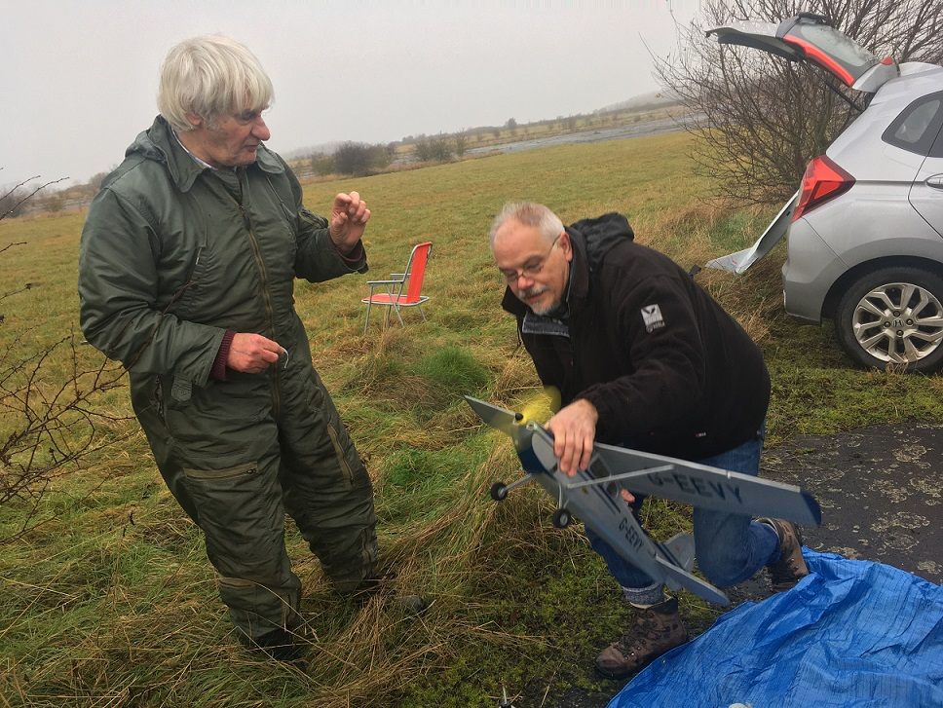
Mind your fingers!
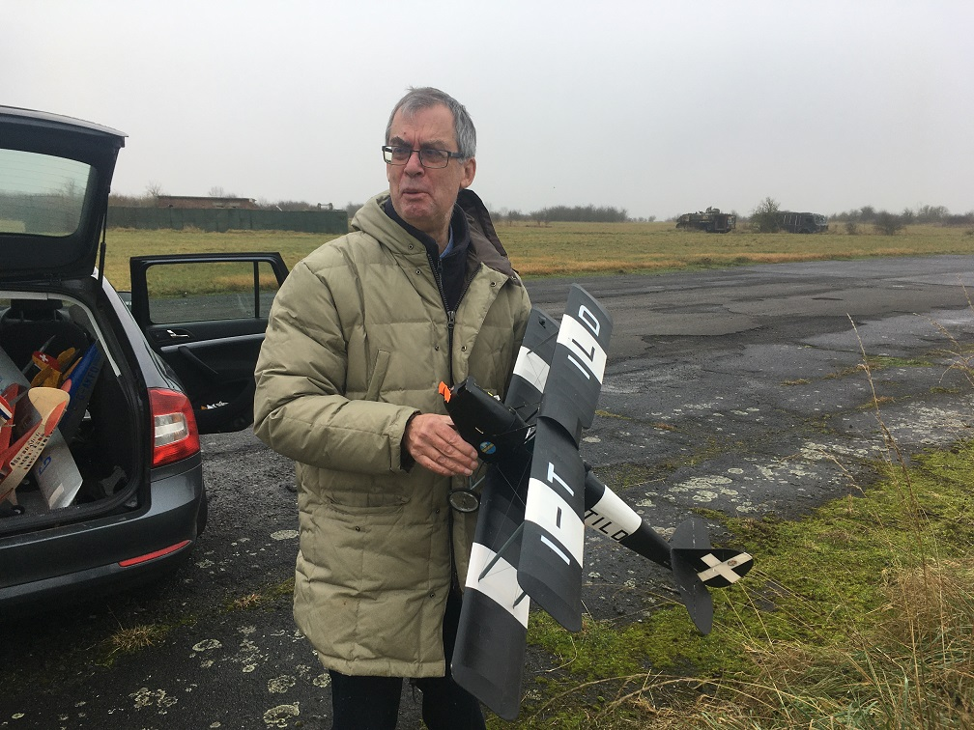
Bill does not look to sure but apparently all went well.
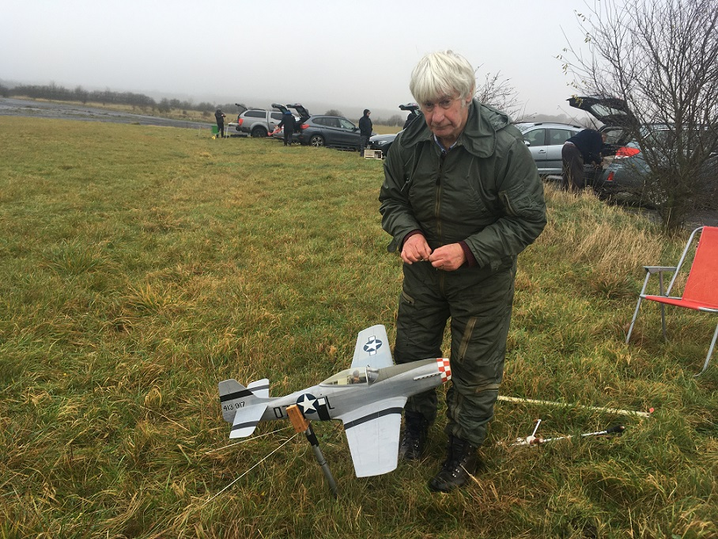

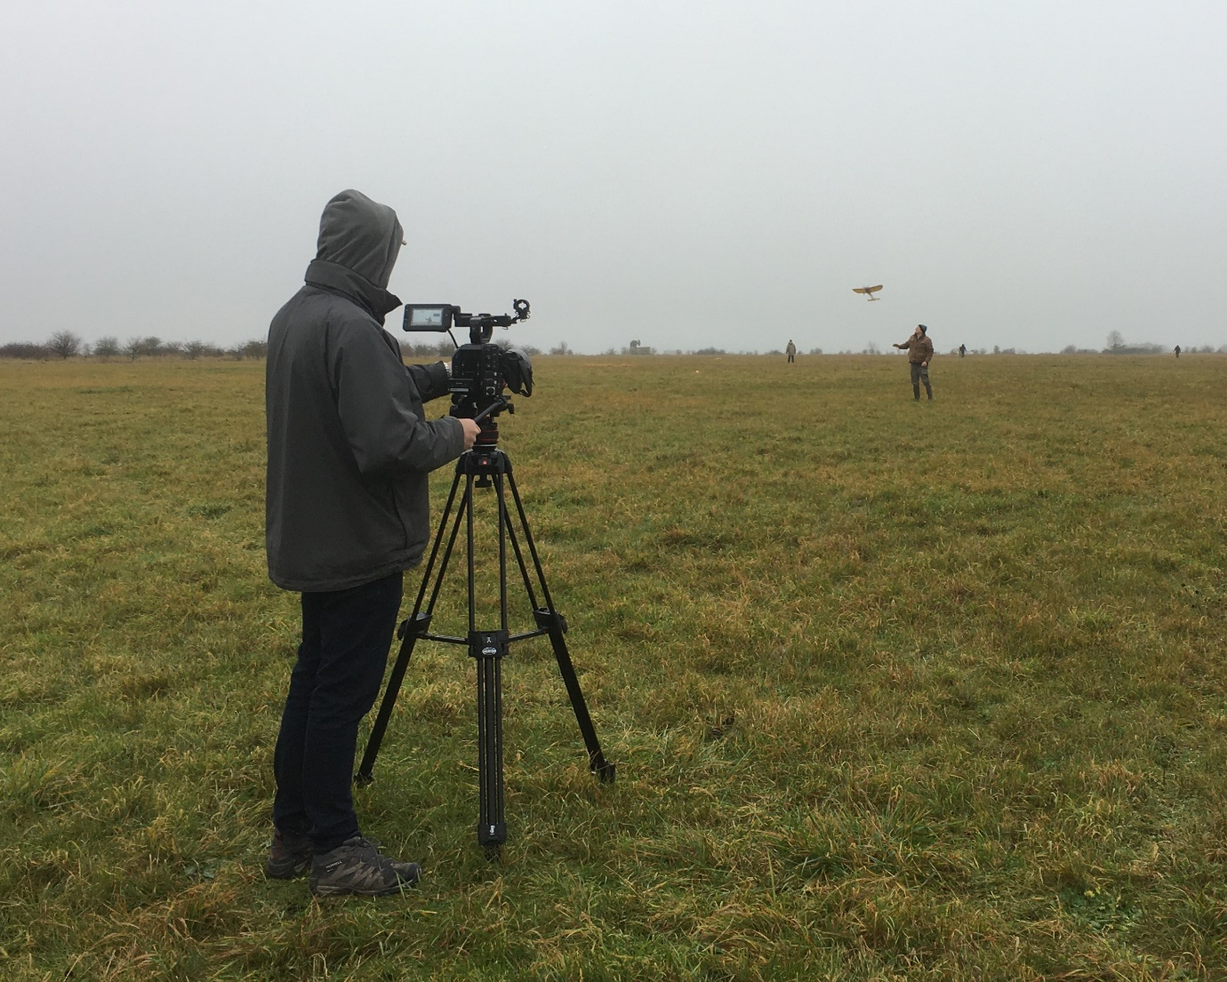
Chris Bradbury Doing his thing behind the camera.
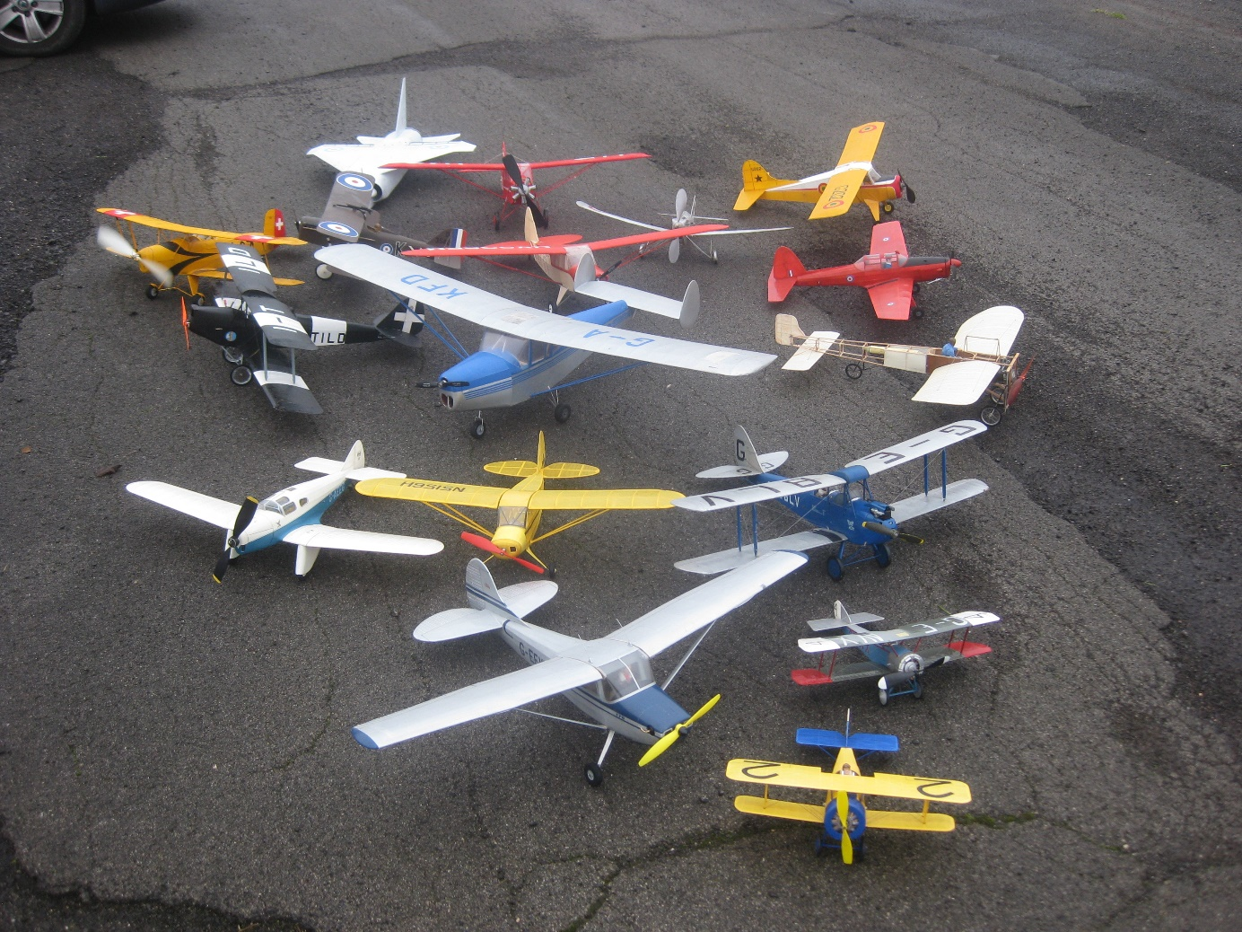

Here is a thought for you. This photo is good but can we take another one at a main meeting next season with all the scale models we collectively fly to demonstrate the strength of interest in Scale Free Flight? How big is the boot of your car? Could be a world beater. Guinness book of records here we come!
100 models would seem an appropriate “BMFA ish” number to aim for.

Mike

