Scale Free Flight Brief No 41 January 2022
Welcome to 2022, keep your fingers crossed.
It has been two years since Doug Hunt came up with the idea and wrote the first few of these Scale Free Flight Briefs. 41 issues later, with 106 subscribers, we are going well and I will endeavour to keep the readership informed.

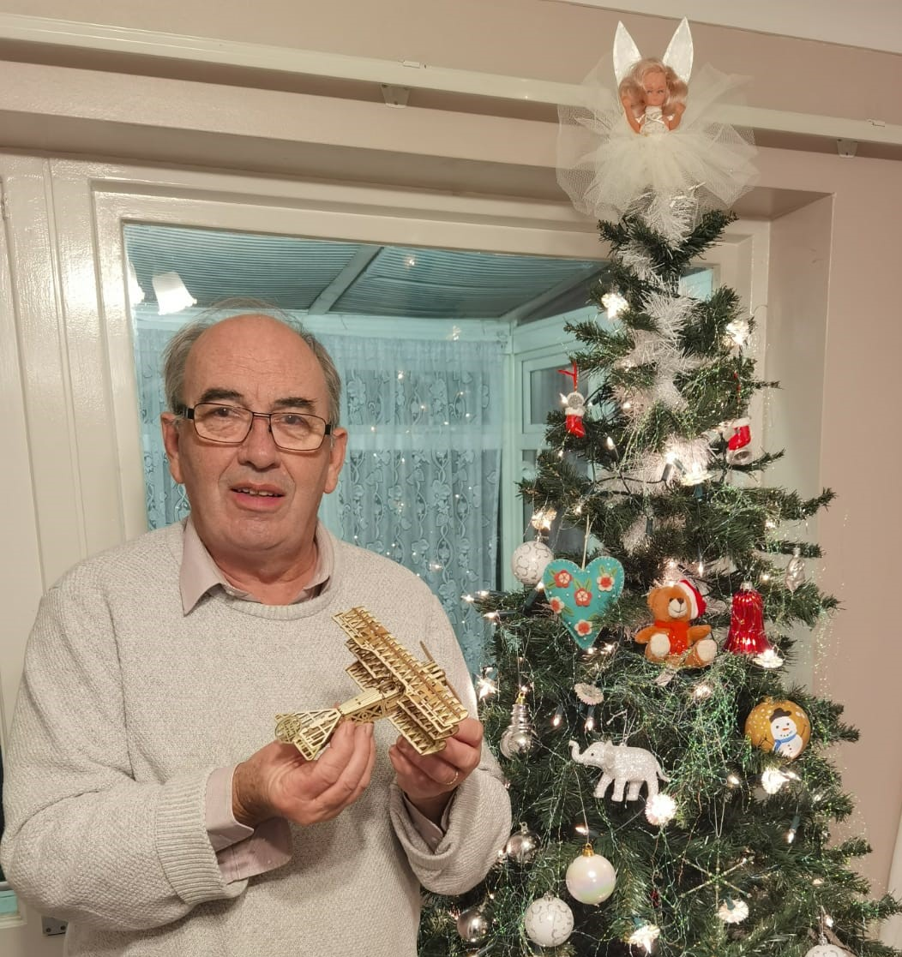

I had hopes for something in my Father Christmas sack and I was not disappointed with this static Fokker Dr1. However, it will not do much in Peanut/Pistachio. Very clever, perfect fit, laser cutting in the kit. This type of model has come a long way since the wonky dinosaurs of the past. (No pun intended)
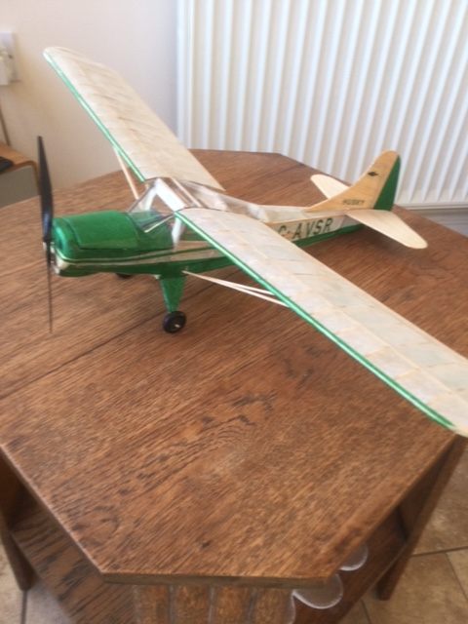
One of our newer enthusiasts sent me these details of his refurbishment of an Aerographics kit. A Beagle Husky. It weighs around 45gm (without the 1s battery) so is a bit heavy for its 21 1/2 in span. The covering is all lightweight tissue of unknown make that came with the kit. The actual full size is shown on the kit box and I’ve followed the scheme as closely as I can. Cutting the green tissue was a bit fiddly as you can imagine. Hoping to see you on a flying field in the not too distant. Some new builds coming up I hope, but I have some maintenance to do on the rest of the fleet first. The Husky was the first of these - built some time ago but needed major alterations to cabin area & wing attachment to be any use. Was plug in wing panels but now a one-piece model. The whole cabin area had to be reglazed as a result.

David, There should be plenty of opportunity to meet up with everyone this season. The Scale Free Flight Calendar is attached.

The usual provisos and caveats apply with regard to the events. Check before you go to a meeting.
Updates will be sent out as and when. There is still a shadow hanging over the availability of Barkston for the FF Nats. Cross your toes this time.

The rule book is now with the BMFA and I await confirmation of publication. I will send it out soonest.

Mike
SCALE FREE FLIGHT CALENDAR 2022
Meeting details are believed to be accurate at the time of issue and subject to Covid restrictions s in place at the time of the event. Check with the event C.D to confirm details before travelling.
BMFA Scale Technical Committee https://scale.bmfa.org/
Scale Free Flight Briefs. Keep up to date with the latest news and receive these updates by email.
Contact Mike Smith michaeldocsmith@gmail.com
Scale Zoom Presentations. Interesting informative presentations dealing with all aspects of scale aeromodelling. Last Wednesday of each month from 8.30pm. https://scale.bmfa.org/calendar
Free Flight Mondays @ BMFA National Centre, Buckminster, Lincolnshire.
Open from 10.00am to dusk with priority for Free Flight. £10.00 for the day.
Check in at reception on arrival. https://nationalcentre.bmfa.org/
Scale Free Flight Days.
Impromptu fly for fun meetings that are weather dependant and short notice. Emails will be sent out to those who are interested when the weather is suitable.
Contact Mike Smith michaeldocsmith@gmail.com
April 23rd Indoor Scale Radio Control Nationals.
Wolverhampton University sports centre.
April 24th Indoor Scale Free Flight Nationals.
Wolverhampton University sports centre.
Details will follow for the two indoor events
May 7th and 8th Modelair Festival of Flight. Old Warden
http://www.modelair.info/ https://www.shuttleworth.org/
Old Warden Aerodrome, Nr Biggleswade, Bedfordshire, SG18 9EP
Sunday Masefield Trophy and Earl Stahl Contests
May 21st or 22nd Lodge Farm Gala
Church Lane, Sleaford NG34 8QU.
Whatthreewords app location marathons.piston.steaming
Flying Only. AM-MAD award and Rubber Precision.
CD Mike Smith michaeldocsmith@gmail.com
June 2nd to June 5th “May” Free Flight Nationals
Saturday Flying Only Credgington Trophy / Aeromodeller Model Aircraft Designs
Friday. Rubber Precision Cup
Saturday. Eddie Riding Contests 3 x open classes and EJR Designs.
Sunday. Flying Only, Credgington Trophy and Scale Free Flight 100 Challenge.
CD Mike Smith michaeldocsmith@gmail.com
June 25th Saturday. SAM 35 Retro- Nats
BMFA National Centre, Buckminster NG33 5RW
Power Precision Two classes: - High Wing, Low Wing/Biplane. (Have a go with your Scale model)
July 2nd and 3rd BMFA Scale Festival
Buckminster
Saturday Evening Rubber Precision.
July 17th Lodge Farm Scale Day (Replacing Old Warden)
Lodge Farm. Church Lane, Sleaford NG34 8QU.
Whatthreewords app location marathons.piston.steaming
Flying Only with Kit Scale award and Rubber Precision
CD Mike Smith michaeldocsmith@gmail.com
TBC July 30th and July 31st Anglia Gala TBC
RAF Sculthorpe. Norfolk. NR21 7RF.
Directions. A148 then B1454. Entrance 100mtr on right.
TAKE YOUR BMFA MEMBERSHIP CARD. You must have proof of BMFA membership before entry.
Absolutely no dogs. No retrieval by motor car.
Contact Mike Woodhouse 01603 457754 michael.woodhouse1942@gmail.com
Sunday. Scale Free Flight Flying Only. (Runways are available)
August 27th 28th 29th BMFA Scale Nationals
RAF Barkston Heath
Free Flight. Open Power, Open CO2 / Electric, Open Rubber, Intermediate.
September 3rd Peterborough Flying Aces
Flying Aces Nationals at Ferry Meadows, Nene Park, Peterborough PE2 5UU. For directions and contests see website. 10.00 to 16.00
http://www.peterboroughmfc.org
Contact Brian Waterland on 01778 343722 (07717 461000 on the day).
September 17th and 18th and 19th Modelair Scale Weekend.
http://www.modelair.info/
Old Warden Aerodrome, Nr Biggleswade, Bedfordshire, SG18 9EP
https://www.shuttleworth.org/
Sunday Rubber Bowden. Entry from 9.30 (Scale welcome. Scale did very well last year)
October 1st or 2nd LODGE FARM SCALE GALA (End of season get together)
Church Lane, Sleaford NG34 8QU.
Whatthreewords app location marathons.piston.steaming
Flying Only and Rubber Precision.

NEW Scale Free Flight Aeromodellers League.
Contests run over the season will be awarded points as below.
1st 10pts. 2nd 8pts. 3rd 6pts. 4th 4pts. 5th 2pts. Other competitors that put in a scoring flight 1pt.
An overall Scale Free Flight Competitor 2022 award will be made. (Bottle of beer and a wooden fork not a spoon)

