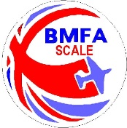 | 2023 FREE FLIGHT  COMPETITOR’S DECLARATION FORM | 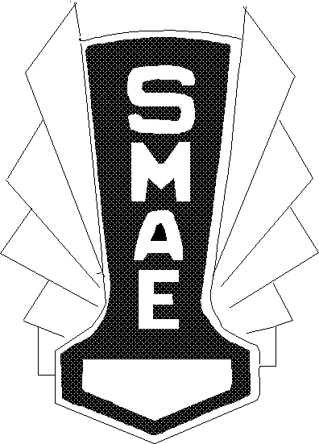

Competitor’s must complete and sign this form to certify that their model conforms to the current class rules.

Name | BMFA No: |  |  |  | Class
Model |  | Weight | Wing Loading | Scale |  | Cruise Speed

You must declare any third-party input to the design, build and finishing of the model and identify any parts of the model that have not been entirely designed and constructed by you. This excludes R/C and electronic equipment, engines, fuel system components and fasteners.
Answer all the questions by entering YES or NO as appropriate In the box -----------------------------------►
Was this model researched, designed and built entirely by you
Was this model built using a commercially available design or plan. If YES state designer…………………….
Was this model built from a kit. If YES, state kit manufacturer’s name …………………………………………
INDICATE IF ANY ITEMS ARE DESIGNED SUPPLIED OR MANUFACTURED BY A THIRD PARTY
If you need more space use the other side of this form and tick this box ------------------------------------------------►
CERTIFICATION
I declare that my model conforms to the BMFA General Rules, Scale General Rules and Scale Class rules and that the answers to the questions are correct.

Signature ……………………………………………………………………Date……………………………………………..

